**MINISTRY OF EDUCATION AND TRAINING**

**FPT UNIVERSITY**

Capstone Project Document

**Vietnamese Sign Language Recognition**

|  |  |
| --- | --- |
| **Group 03** | |
| **Group members** | Nguyễn Hữu Kỳ Long – Team leader – SE60984  Nguyễn Đình Tân – Team member – SE61115  Nguyễn Xuân Ý – Team member – SE60869  Lê Phương Bình – Team member – SE61049 |
| **Supervisor** | Mr. Đỗ Đức Minh Quân |
| **Ext. Supervisor** | N/A |
| **Capstone Project code** | VSLR |

-Ho Chi Minh City, 18/06/2015-

*This page is intentionally left blank*

# Table of Contents

[Table of Contents 3](#_Toc417274757)

[List of Tables 3](#_Toc417274758)

[Definitions, Acronyms, and Abbreviations 4](#_Toc417274759)

[A. Report No. 4 Software Design Description 5](#_Toc417274760)

[1. Design Overview 5](#_Toc417274761)

[2. System Architectural Design 5](#_Toc417274762)

[3. Component Diagram 7](#_Toc417274763)

[4. Detailed Description 8](#_Toc417274764)

[1.1 Class Diagram 8](#_Toc417274765)

[1.2 Class Diagram Explanation 8](#_Toc417274766)

[1.3 Sequence Diagram 12](#_Toc417274767)

[1.4 Activity Diagram 25](#_Toc417274768)

[2. User Interface Design 27](#_Toc417274769)

[2.1 Admin Interface Design 27](#_Toc417274770)

[2.2 Storeowner Interface Design (Website) 31](#_Toc417274771)

[4.1 Employee Interface Design 51](#_Toc417274772)

[3. Database Design 60](#_Toc417274773)

[3.1 Logical Diagram 60](#_Toc417274774)

[3.2 Data Dictionary 61](#_Toc417274775)

[4. Algorithms 63](#_Toc417274776)

[4.1 K-Medoids Algorithm 63](#_Toc417274777)

[4.2 Create a printable order 66](#_Toc417274778)

# List of Tables

[Table 1: Entity Data Dictionary 61](#_Toc417274779)

[Table 2: Detail Data Dictionary 63](#_Toc417274780)

# Definitions, Acronyms, and Abbreviations

|  |  |
| --- | --- |
| **Name** | **Definition** |
| VSLR | Vietnamese Sign Language Recognition |
|  |  |
|  |  |
|  |  |

# Report No. 4 Software Design Description

## Design Overview

* This document describes the technical and user interface design of VSLR System. It includes the architectural design, the detailed design of common functions and business functions and the design of database model.
* The architectural design describes the overall architecture of the system and the architecture of each main component and subsystem.
* The detailed design describes static and dynamic structure for each component and functions. It includes class diagrams, class explanations and sequence diagrams for each use cases.
* The database design describes the relationships between entities and details of each entity.
* Document overview:
* Section 2: gives an overall description of the system architecture design.
* Section 3: gives component diagrams that describe the connection and integration of the system.
* Section 4: gives the detail design description, which includes class diagram, class explanation, and sequence diagram to details the application functions.
* Section 5: describe a fully attributed ERD.

## System Architectural Design

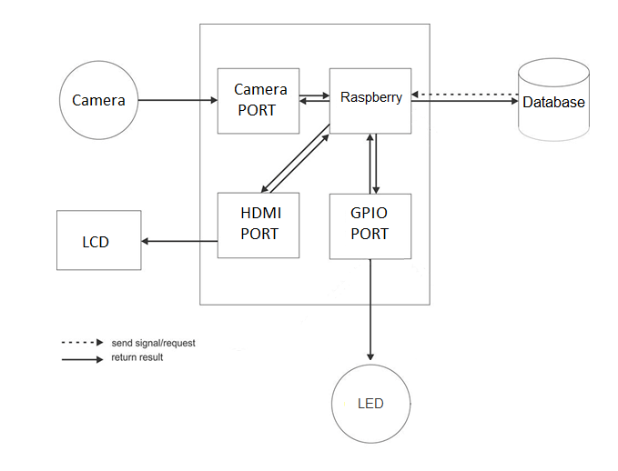

Figure 4: VSLR System Architectural



#### Web application architecture description

* The system is developed from MVC architecture style and customized with passive model to adapt to JAVA MVC, RESTful web service technologies.
* **Model** is a part of application which uses to storage and retrieval data.
* **View** is the part of the application that visualizes the data to help user easily to view, update or customize them.
* **Controller** is the parts of the application that acts like event handler to handles user interaction. Typically controller read data from a request and returns respective view for user.
* **Web Service** is the parts of the application which use to provide interface for mobile application to do some background operation such as download template, convert excel file...

#### Mobile application architecture description

* The application is developed as an Android native application. In general, the application architecture conforms to Android architecture.
* **Activity** is the basic core of an android application that handles user input, calls Web Service…
* **Data Transfer Object** is the parts of the application that mapping to SQLite database to storage and retrival the order and order detail which assigned for employee.

## Component Diagram

**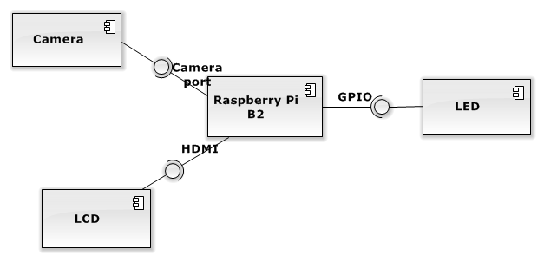**

Figure 5: Component Diagram

## Detailed Description

4.1. Hardware layer

4.1.1. Raspberry Pi B2

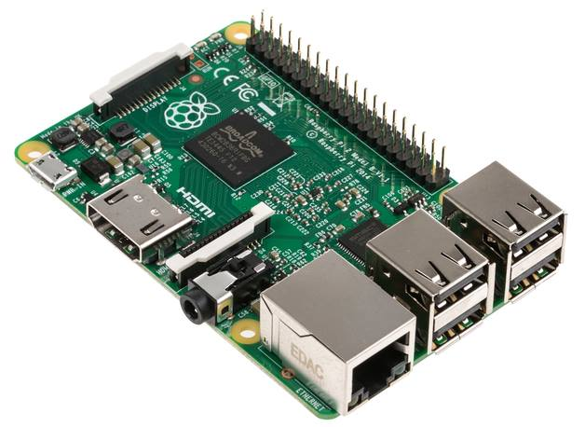

Figure 33. Raspberry Pi B2 Kit

The Raspberry Pi is a low cost, **credit-card sized computer** that plugs into a computer monitor or TV, and uses a standard keyboard and mouse. It is a capable little device that enables people of all ages to explore computing, and to learn how to program in languages like Scratch and Python. It’s capable of doing everything you’d expect a desktop computer to do, from browsing the internet and playing high-definition video, to making spreadsheets, word-processing, and playing games.

***FOR***

* Quad-core CPU
* Backwards compatible
* More RAM
* Will fit existing cases

***AGAINST***

* Could prove intimidating for Linux newcomers
* No micro-USB adapter included

Raspberry Pi B2 specification :

SoC: Broadcom 2836  
CPU: Quad-core ARM7 800MHz  
GPU: Videocore IV 250MHz  
Memory: 1GB  
GPIO: 40pin  
Ports: 4x USB 2.0, 100BaseT Ethernet, HDMI, MicroSD card  
Size: 85.60 × 56.5mm (about 3.2 x 2.1-inch)

### Class Diagram

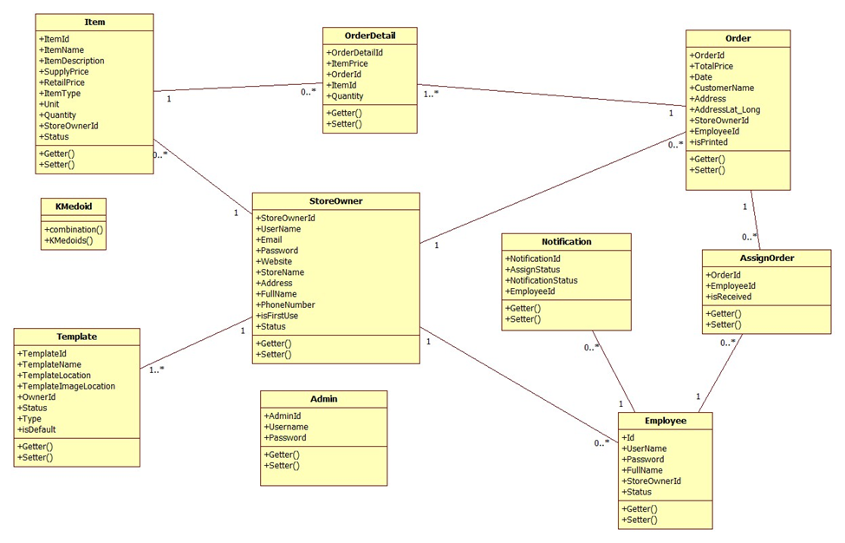

Figure 2: Class Diagram

### Class Diagram Explanation

#### StoreOwner

Attribute

|  |  |  |  |
| --- | --- | --- | --- |
| **Attribute** | **Type** | **Visibility** | **Description** |
| StoreOwnerId | int | Private | Unique identifier of a storeowner |
| UserName | String | Private | Username of storeowner |
| Email | String | Private | Email of storeowner |
| Password | String | Private | Password of storeowner |
| Website | String | Private | Website address of storeowner |
| StoreName | String | Private | Name of the store |
| Address | String | Private | Address of the store |
| FullName | String | Private | Full name of storeowner |
| PhoneNumber | String | Private | Phone number of storeowner |
| isFirstUse | boolean | Private | Value to check whether storeowner log in for the first time or not |
| Status | String | Private | Status of storeowner |

Method

|  |  |  |  |
| --- | --- | --- | --- |
| **Method** | **Return type** | **Visibility** | **Description** |
| Getter | Attribute type | Public | Get attribute value |
| Setter | Void | Public | Set value of attribute |

#### Employee

Attribute

|  |  |  |  |
| --- | --- | --- | --- |
| **Attribute** | **Type** | **Visibility** | **Description** |
| Id | int | Private | Unique identifier of an employee |
| UserName | String | Private | Username of employee |
| Password | String | Private | Password of employee |
| FullName | String | Private | Full name of employee |
| StoreOwnerId | int | Private | Id of storeowner |
| Status | String | Private | Status of an employee |

Method

|  |  |  |  |
| --- | --- | --- | --- |
| **Method** | **Return type** | **Visibility** | **Description** |
| Getter | Attribute type | Public | Get attribute value |
| Setter | Void | Public | Set value of attribute |

#### Item

Attribute

|  |  |  |  |
| --- | --- | --- | --- |
| **Attribute** | **Type** | **Visibility** | **Description** |
| ItemId | int | Private | Unique identifier of an item |
| ItemName | String | Private | Name of an item |
| ItemDescription | String | Private | Description about item |
| SupplyPrice | float | Private | Supply price of item |
| RetailPrice | float | Private | Retail price of item |
| ItemType | String | Private | Type of item |
| Unit | String | Private | Calculating unit of item |
| Quantity | int | Private | Quantity of item in store |
| StoreOwnerId | int | Private | Id of storeowner |
| Status | String | Private | Status of an item |

Method

|  |  |  |  |
| --- | --- | --- | --- |
| **Method** | **Return type** | **Visibility** | **Description** |
| Getter | Attribute type | Public | Get attribute value |
| Setter | Void | Public | Set value of attribute |

#### Template

Attribute

|  |  |  |  |
| --- | --- | --- | --- |
| **Attribute** | **Type** | **Visibility** | **Description** |
| TemplateId | int | Private | Unique identifier of a template |
| TemplateName | String | Private | Name of template |
| TemplateLocation | String | Private | Location of template on server |
| TemplateImageLocation | String | Private | Location of template’s image on server |
| OwnerId | int | Private | Id of template’s owner |
| Status | String | Private | Status of template |
| Type | String | Private | Type of template |
| isDefault | boolean | Private | Value to check whether template is a default template or not |

Method

|  |  |  |  |
| --- | --- | --- | --- |
| **Method** | **Return type** | **Visibility** | **Description** |
| Getter | Attribute type | Public | Get attribute value |
| Setter | Void | Public | Set value of attribute |

#### Order

Attribute

|  |  |  |  |
| --- | --- | --- | --- |
| **Attribute** | **Type** | **Visibility** | **Description** |
| OrderId | int | Private | Unique identifier of an order |
| TotalPrice | float | Private | Total price of order |
| Date | String | Private | Date order was created |
| CustomerName | String | Private | Name of customer |
| Address | String | Private | Address of customer |
| AddressLat\_Long | String | Private | Latitude and longitude of customer’s address |
| StoreOwnerId | int | Private | Id of storeowner |
| isPrinted | boolean | Private | Value to check whether order is a printed or not |

Method

|  |  |  |  |
| --- | --- | --- | --- |
| **Method** | **Return type** | **Visibility** | **Description** |
| Getter | Attribute type | Public | Get attribute value |
| Setter | Void | Public | Set value of attribute |

#### Order Detail

Attribute

|  |  |  |  |
| --- | --- | --- | --- |
| **Attribute** | **Type** | **Visibility** | **Description** |
| OrderDetailId | int | Private | Unique identifier of an order detail |
| ItemPrice | float | Private | Price of an item |
| OrderId | int | Private | Id of order |
| ItemId | int | Private | Id of item |
| Quantity | Int | Private | Number of item |

Method

|  |  |  |  |
| --- | --- | --- | --- |
| **Method** | **Return type** | **Visibility** | **Description** |
| Getter | Attribute type | Public | Get attribute value |
| Setter | Void | Public | Set value of attribute |

#### Notification

Attribute

|  |  |  |  |
| --- | --- | --- | --- |
| **Attribute** | **Type** | **Visibility** | **Description** |
| NotificationId | int | Private | Unique identifier of notification |
| AssignStatus | boolean | Private | Status of order assigned to employee |
| NofiticationStatus | boolean | Private | Status of notification |
| EmployeeId | int | Private | Id of employee |

Method

|  |  |  |  |
| --- | --- | --- | --- |
| **Method** | **Return type** | **Visibility** | **Description** |
| Getter | Attribute type | Public | Get attribute value |
| Setter | Void | Public | Set value of attribute |

#### AssignOrder

Attribute

|  |  |  |  |
| --- | --- | --- | --- |
| **Attribute** | **Type** | **Visibility** | **Description** |
| OrderId | int | Private | Id of order |
| EmployeeId | int | Private | Id of employee |
| isReceived | boolean | Private | Value to check whether order is a received or not |

Method

|  |  |  |  |
| --- | --- | --- | --- |
| **Method** | **Return type** | **Visibility** | **Description** |
| Getter | Attribute type | Public | Get attribute value |
| Setter | Void | Public | Set value of attribute |

#### Admin

Attribute

|  |  |  |  |
| --- | --- | --- | --- |
| **Attribute** | **Type** | **Visibility** | **Description** |
| AdminId | int | Private | Unique identifier of admin |
| UserName | String | Private | Username of admin |
| Password | String | Private | Password of admin |

Method

|  |  |  |  |
| --- | --- | --- | --- |
| **Method** | **Return type** | **Visibility** | **Description** |
| Getter | Attribute type | Public | Get attribute value |
| Setter | Void | Public | Set value of attribute |

#### K – Medoid

Method

|  |  |  |  |
| --- | --- | --- | --- |
| **Method** | **Return type** | **Visibility** | **Description** |
| Combination | String Array | Public | Calculation combination of medoid |
| KMedoids | 2-Dementions String Array | Public | Implement Kmedoid algorithm. |

### Sequence Diagram

##### <Guest> Register

**Summary:** This diagram shows how to guest register as StoreOwner.

**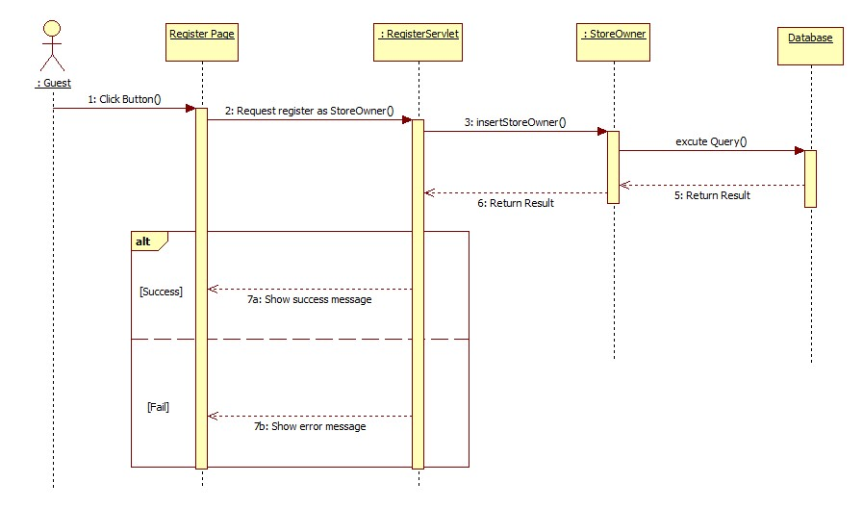**

Figure 29: <Guest> Register

##### <Guest> Login

**Summary:** This diagram shows how to guest login as StoreOwner.

**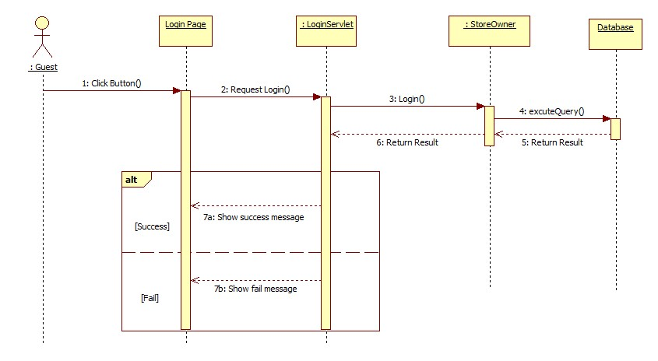**

Figure 30: <Guest> Login

##### <StoreOwner> Insert Item

**Summary:** This diagram shows how a StoreOwner insert new item to system.

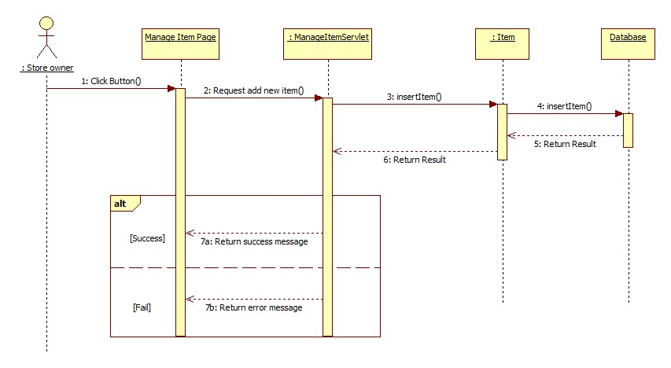

Figure 31: <StoreOwner> Insert Item

##### <StoreOwner> Update Item

**Summary:** This diagram shows how a StoreOwner updates an existed item.

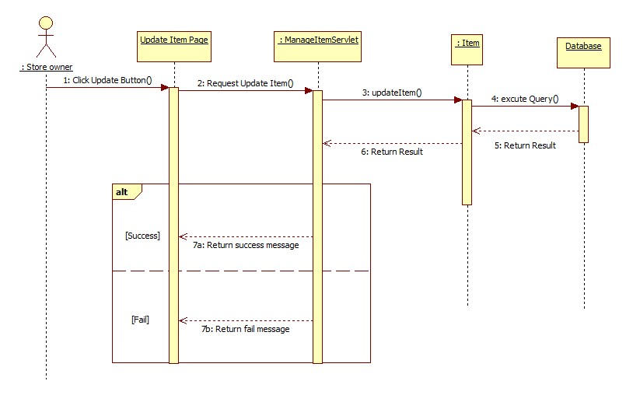

Figure 32: <StoreOwner> Update Item

##### <StoreOwner> Change Item Status

**Summary:** This diagram shows how a StoreOwner locks or unlocks an item in system.

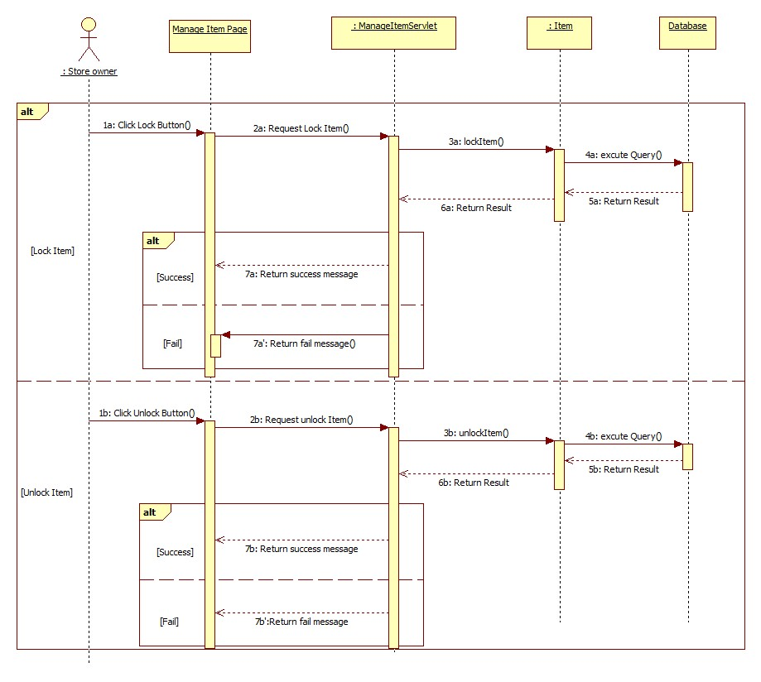

Figure 33: <StoreOwner> Change Item Status

##### <StoreOwner> Import Item

**Summary:** This diagram shows how a StoreOwner import a list of Item into system.

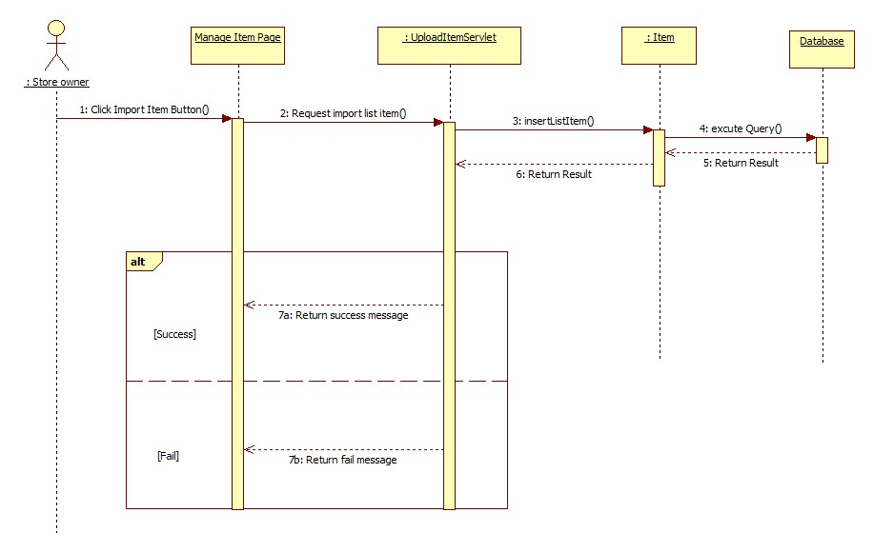

Figure 34: <StoreOwner> Import Item

##### <StoreOwner> Insert Employee

**Summary:** This diagram shows how a StoreOwner a new employee to system.

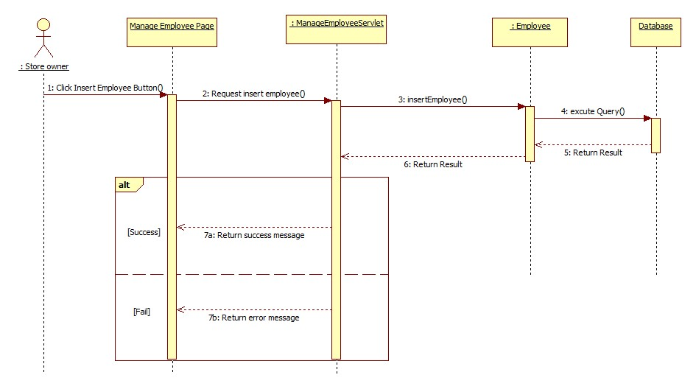

Figure 35: <StoreOwner> Insert Employee

##### <StoreOwner> Update Employee

**Summary:** This diagram shows how a StoreOwner update employee in system.

**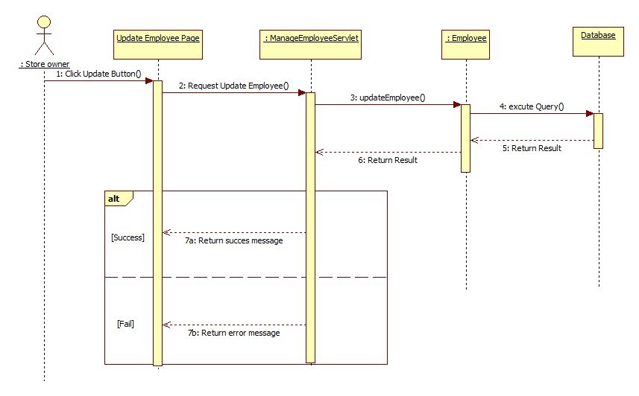**

Figure 36: <StoreOwner> Update Employee

##### <StoreOwner> Change Employee Status

**Summary:** This diagram shows how a StoreOwner changes status of an employee.

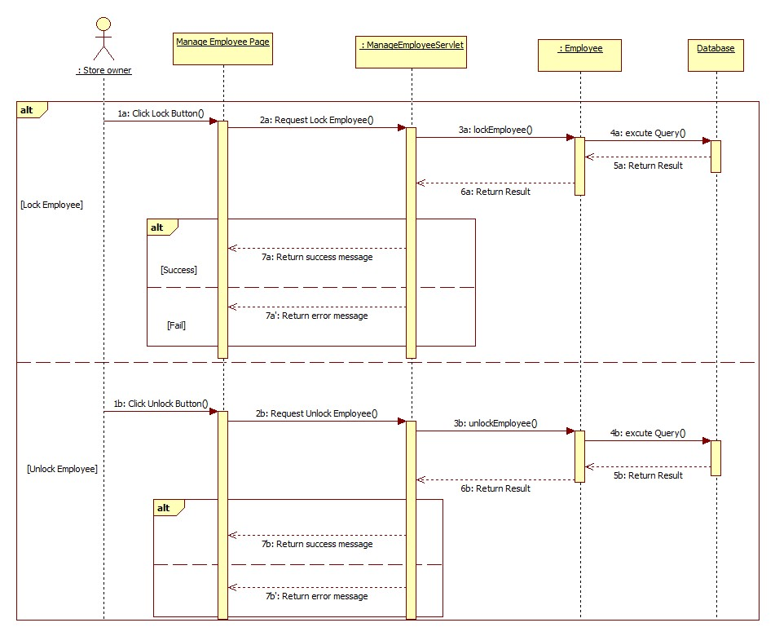

Figure 37: <StoreOwner> Change Employee Status

##### <StoreOwner> Import Employee

**Summary:** This diagram shows how a StoreOwner import a list of Employee into system.

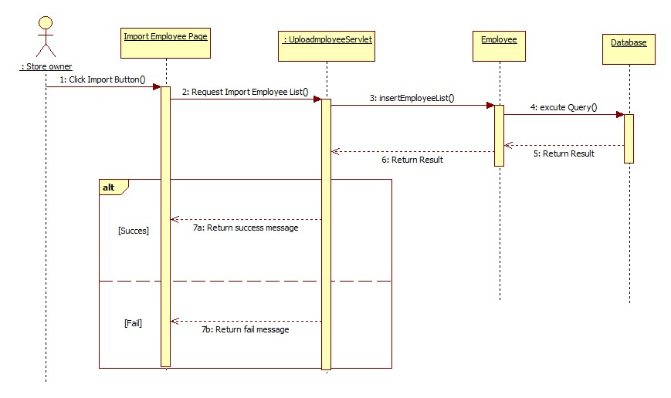

Figure 38: <StoreOwner> Import Employee

##### <StoreOwner> Select Template

**Summary:** This diagram shows how a StoreOwner select template to use when they login for the first time.

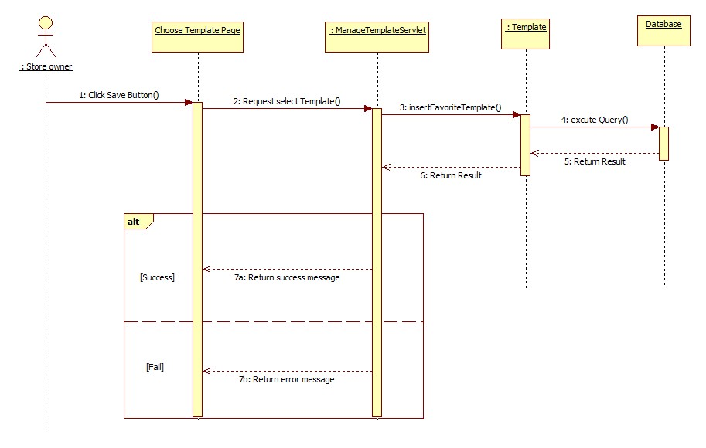

Figure 39: <StoreOwner> Select Template

##### <StoreOwner> Set Template Default

**Summary:** This diagram shows how a StoreOwner set default template to use.

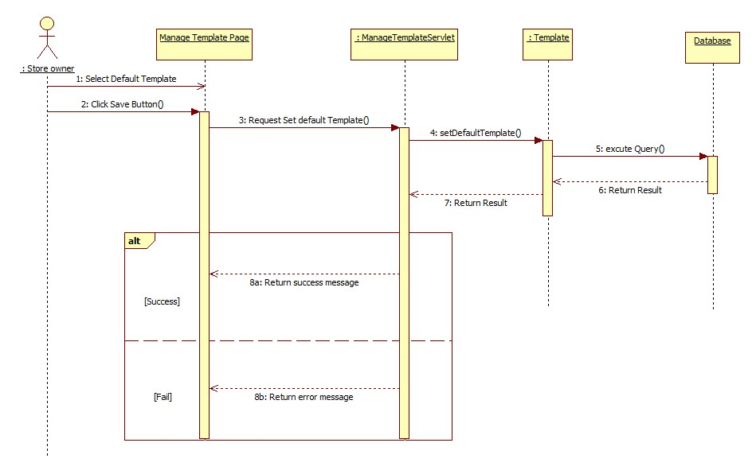

Figure 40: <StoreOwner> Set Template Default

##### <StoreOwner> Custom Template

**Summary:** This diagram shows how a StoreOwner customize template.

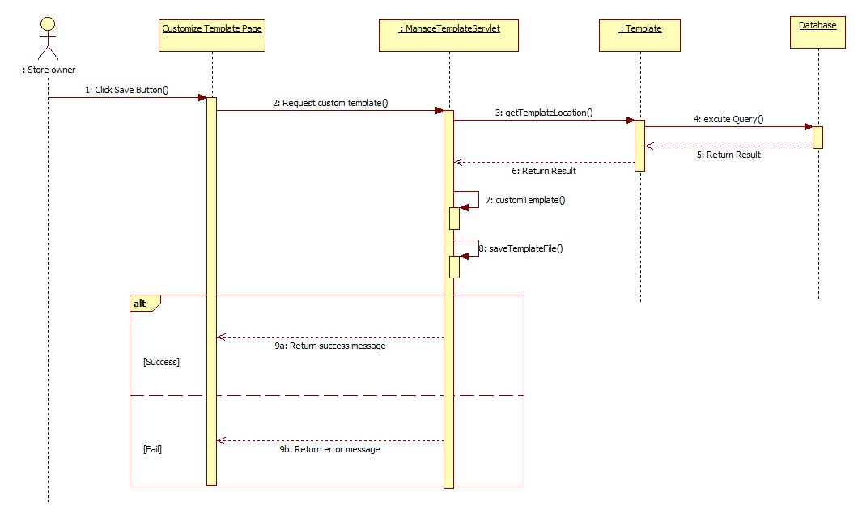

Figure 41: <StoreOwner> Custom Template

##### <StoreOwner> Create Order

**Summary:** This diagram shows how a StoreOwner creates an order.

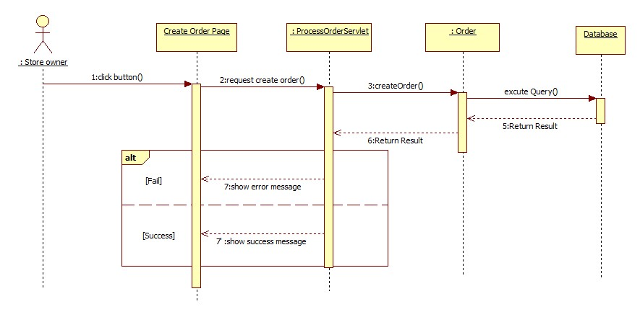

Figure 4: <StoreOwner> Create Order

##### <StoreOwner> Print Order

**Summary:** This diagram shows how a StoreOwner prints an order.

**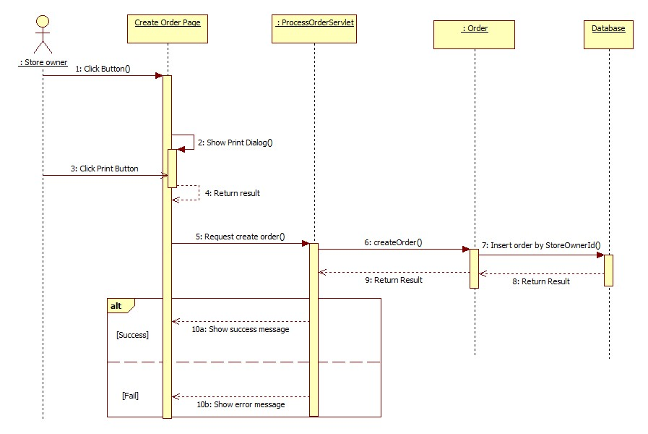**

Figure 42: <StoreOwner> Print Order

##### <StoreOwner> Assign Order

**Summary:** This diagram shows how a StoreOwner assigns orders for their employee to print.

**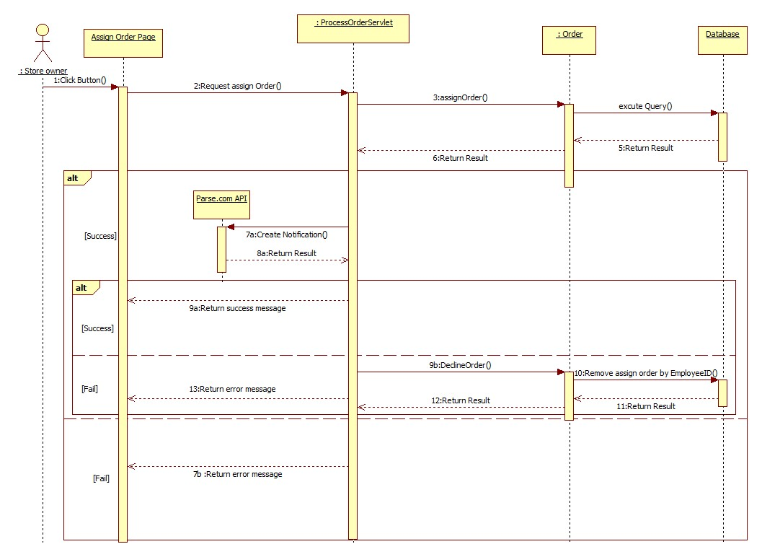**

Figure 43: <StoreOwner> Assign Order

##### <StoreOwner> Suggest Assign Order

**Summary:** This diagram shows how Suggest Assign Order function which help StoreOwner make a suitable assigment.

**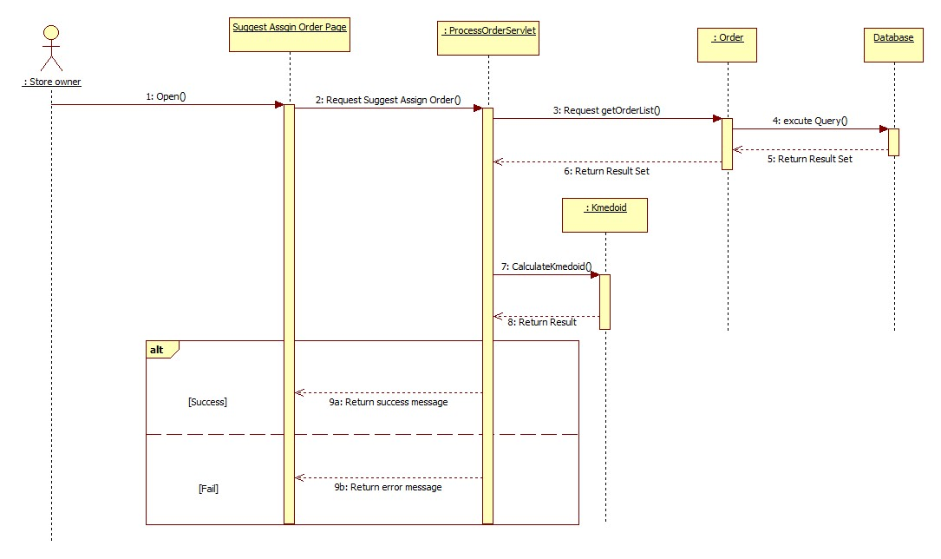**

Figure 44: <StoreOwner> Suggest Assign Order

##### <Admin> Upload Template

**Summary:** This diagram shows how Admin upload new template into system.

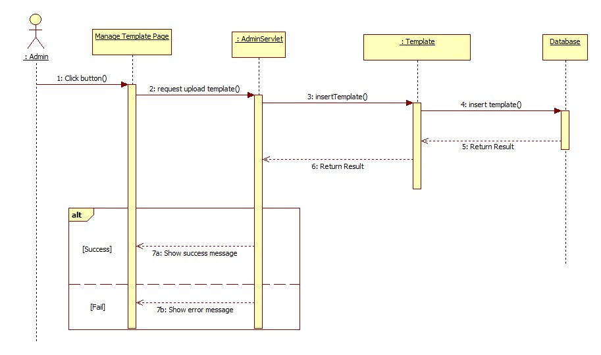

Figure 45: <Admin> Upload Template

##### <Admin> Delete Template

**Summary:** This diagram shows how Admin delete a template from system.

**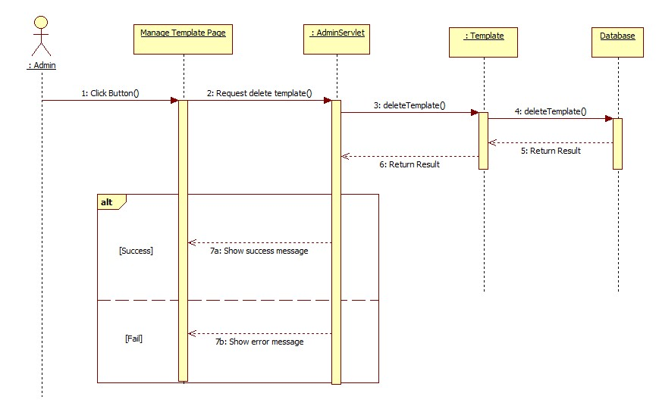**

Figure 46: <Admin> Delete Template

##### <Admin> Change StoreOwner Status

**Summary:** This diagram shows how Admin changes status of StoreOwner.

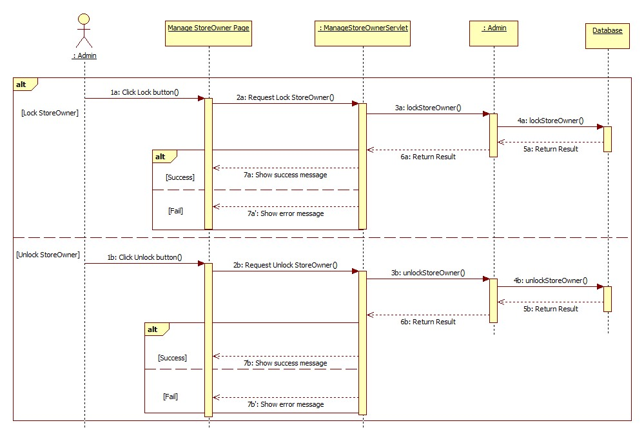

Figure 47: <Admin> Change StoreOwner Status

### Activity Diagram

#### <Employee> Get Assigned Order

**Summary:** This diagram shows how Employee gets orders, which assigned for them.

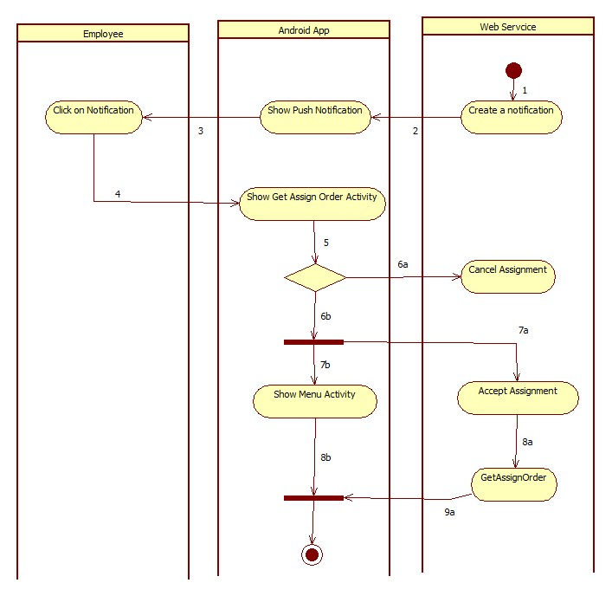

|  |  |  |  |
| --- | --- | --- | --- |
| 1. Start | 2. Call Parse.com API to push the notification to employee’s phone | 3.Show notification | 4. Employee clicks to view notification’s info |
| 5. Employee response to the notification | 6a. Employee cancel assignment | 6b. Employee accept assignment | 7a. Response accept message to server. |
| 7b. Start Activity | 8a. Call GetAssignOrder() | 9a. Response order’s detail |  |

Figure 48: <Employee> Get Assigned Order

#### <Employee> Create Order

**Summary:** This diagram shows how Employee creates a new order on Android phone.

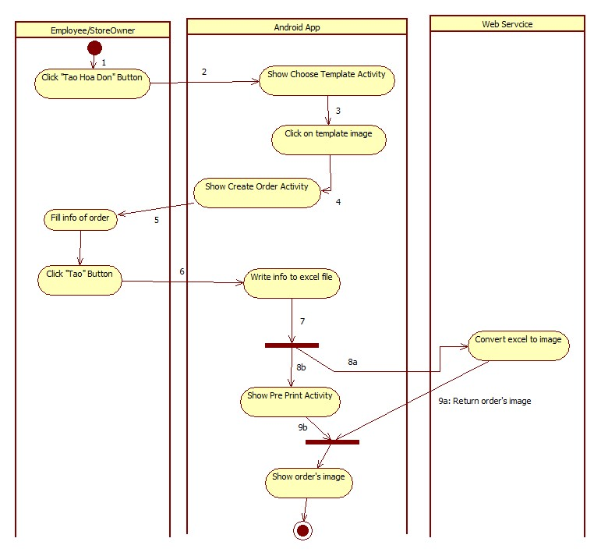

|  |  |  |
| --- | --- | --- |
| 1. Start | 2. Start Activity | 3. Employee select template |
| 4. Start Activity | 5.Employee fill info of order | 6. Click on “Tạo” button to create order. |
| 8a. Call API to convert excel file to image | 8b. Start Activity | 9a. Return Order’s image. |

Figure 49: <Employee> Create Order

#### <Employee> Print Order

**Summary:** This diagram shows how Employee prints a order.

**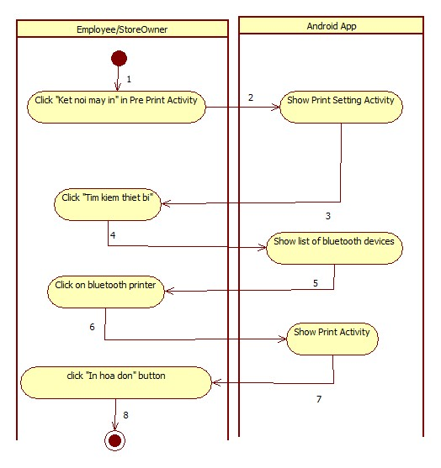**

|  |  |  |
| --- | --- | --- |
| 1. Start | 2. Start Activity | 3. Employee find bluetooth printer. |
| 4. Get search result | 5. Clicks on suitable device | 6. Start Activity |
| 7. Input Number of copy | 8.Finish |  |

Figure 50: <Employee> Print Order

## User Interface Design

### Admin Interface Design

#### Admin Login

**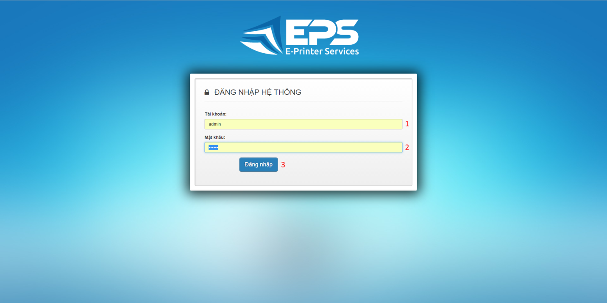**

Figure 1: Admin Login

**Fields**

|  |  |  |  |  |  |  |  |
| --- | --- | --- | --- | --- | --- | --- | --- |
| **No** | **Field Name** | **Description** | **Read only** | **Mandatory** | **Control Type** | **Data Type** | **Length** |
| 1 | Username | Fill user name | No | Yes | Textbox | String | N/A |
| 2 | Password | Fill password | No | Yes | Password | String | N/A |

**Buttons/Hyperlinks**

|  |  |  |  |  |
| --- | --- | --- | --- | --- |
| **No** | **Function** | **Description** | **Validation** | **Outcome** |
| 3 | Sign in | Log-in into the system | N/A | Transfer to admin home page |

#### Admin Manage Templates

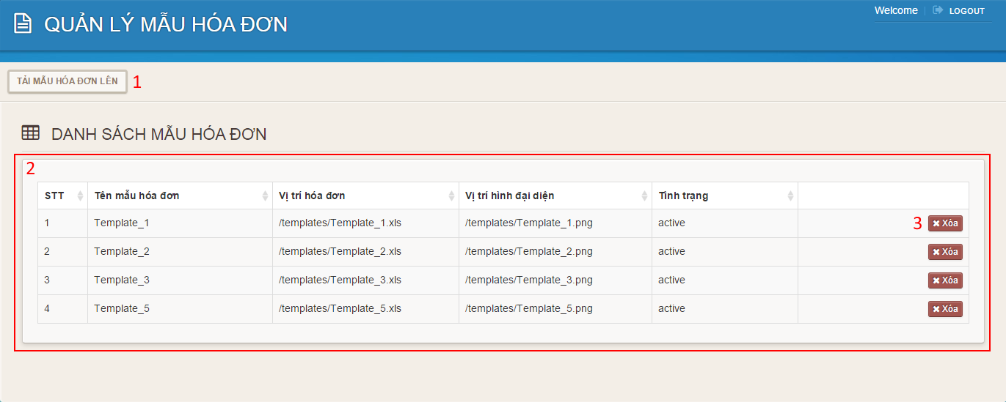

Figure 2: Admin Manage Templates

**Fields**

|  |  |  |  |  |  |  |  |
| --- | --- | --- | --- | --- | --- | --- | --- |
| **No** | **Field Name** | **Description** | **Read only** | **Mandatory** | **Control Type** | **Data Type** | **Length** |
| 2 | Template’s table | Table to show templates | Yes | N/A | Data Table | N/A | N/A |

**Buttons/Hyperlinks**

|  |  |  |  |  |
| --- | --- | --- | --- | --- |
| **No** | **Function** | **Description** | **Validation** | **Outcome** |
| 1 | Upload Template | Click to go to upload template page. | N/A | Transfer to upload template page. |
| 3 | Delete | Delete template | N/A | Delete a template |

#### Admin Upload Template

**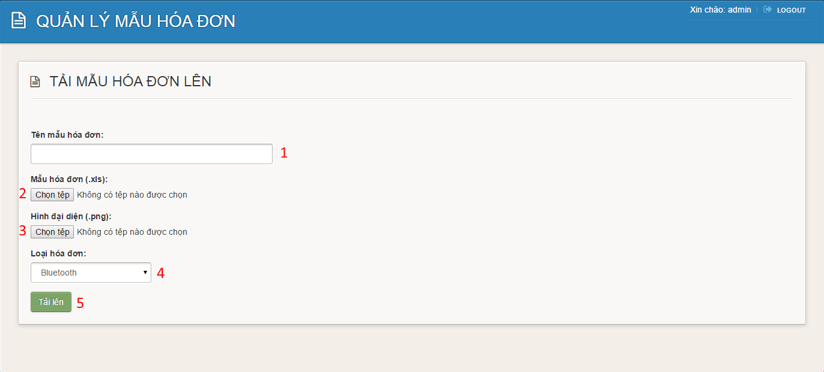Figure 3: Admin Upload Template**

**Fields**

|  |  |  |  |  |  |  |  |
| --- | --- | --- | --- | --- | --- | --- | --- |
| **No** | **Field Name** | **Description** | **Read only** | **Mandatory** | **Control Type** | **Data Type** | **Length** |
| 1 | Template’s name | Fill template’s name | No | Yes | Textbox | String | N/A |
| 4 | Template’s type | Choose template’s type | No | Yes | Comboxbox | String | N/A |

**Buttons/Hyperlinks**

|  |  |  |  |  |
| --- | --- | --- | --- | --- |
| **No** | **Function** | **Description** | **Validation** | **Outcome** |
| 2 | Choose .xls file | Click to go to choose file dialog | N/A | Display choose file dialog |
| 3 | Choose .png file | Click to go to choose file dialog | N/A | Display choose file dialog |
| 5 | Upload template | Click to upload template | N/A | Transfer to manage template page |

#### Admin Manage Storeowners

**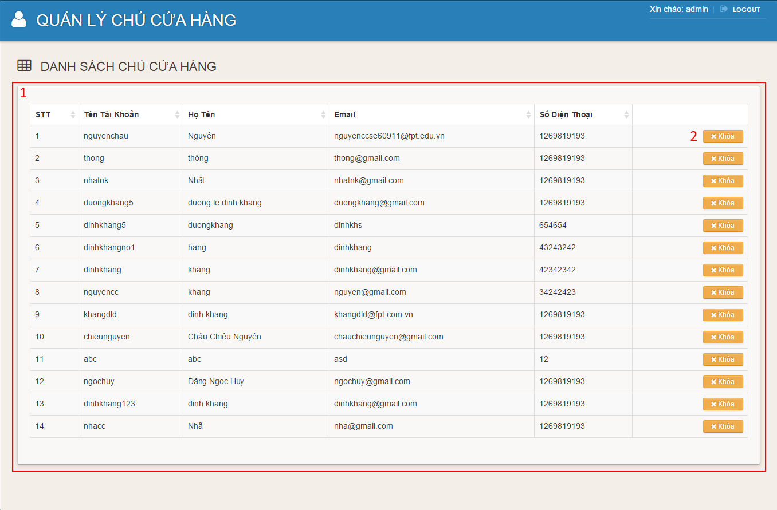Figure 4: Admin Manage Storeowners**

**Fields**

|  |  |  |  |  |  |  |  |
| --- | --- | --- | --- | --- | --- | --- | --- |
| **No** | **Field Name** | **Description** | **Read only** | **Mandatory** | **Control Type** | **Data Type** | **Length** |
| 1 | Storeowner’s table | Table to show storeowners | Yes | No | Data Table | N/A | N/A |

**Buttons/Hyperlinks**

|  |  |  |  |  |
| --- | --- | --- | --- | --- |
| **No** | **Function** | **Description** | **Validation** | **Outcome** |
| 2 | Lock | Click to lock storeowner | N/A | Transfer to manage storeowners page |

### Storeowner Interface Design (Website)

#### Register

**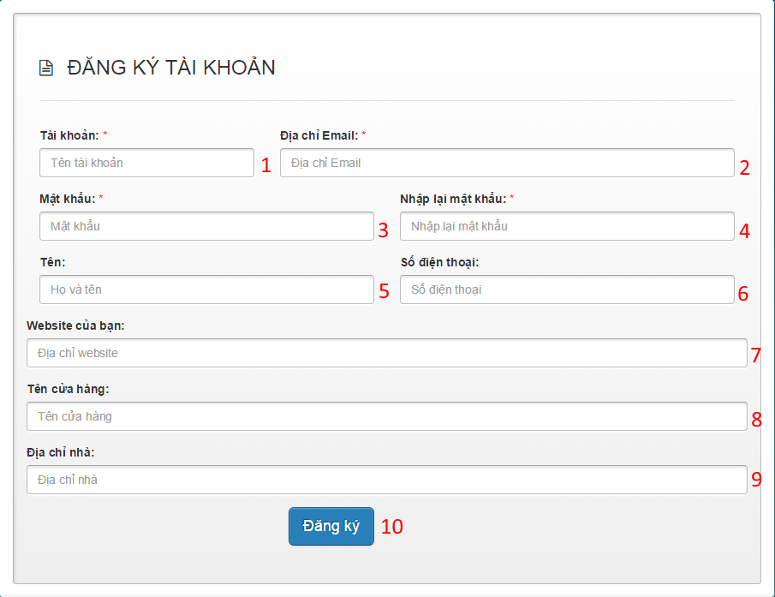Figure 5: Register**

**Fields**

|  |  |  |  |  |  |  |  |
| --- | --- | --- | --- | --- | --- | --- | --- |
| **No** | **Field Name** | **Description** | **Read only** | **Mandatory** | **Control Type** | **Data Type** | **Length** |
| 1 | Username | Fill username | No | Yes | Textbox | String | N/A |
| 2 | Email | Fill email address | No | Yes | Textbox | String | N/A |
| 3 | Password | Fill password | No | Yes | Password | String | N/A |
| 4 | Confirm password | Fill confirm password | No | Yes | Password | String | N/A |
| 5 | Full name | Fill full name | No | No | Textbox | String | N/A |
| 6 | Phone number | Fill phone number | No | No | Textbox | String | N/A |
| 7 | Website | Fill website | No | No | Textbox | String | N/A |
| 8 | Store name | Fill store name | No | No | Textbox | String | N/A |
| 9 | Address | Fill address | No | No | Textbox | String | N/A |

**Buttons/Hyperlinks**

|  |  |  |  |  |
| --- | --- | --- | --- | --- |
| **No** | **Function** | **Description** | **Validation** | **Outcome** |
| 10 | Register | Click to register | N/A | Transfer to welcome page |

#### Storeowner Login

**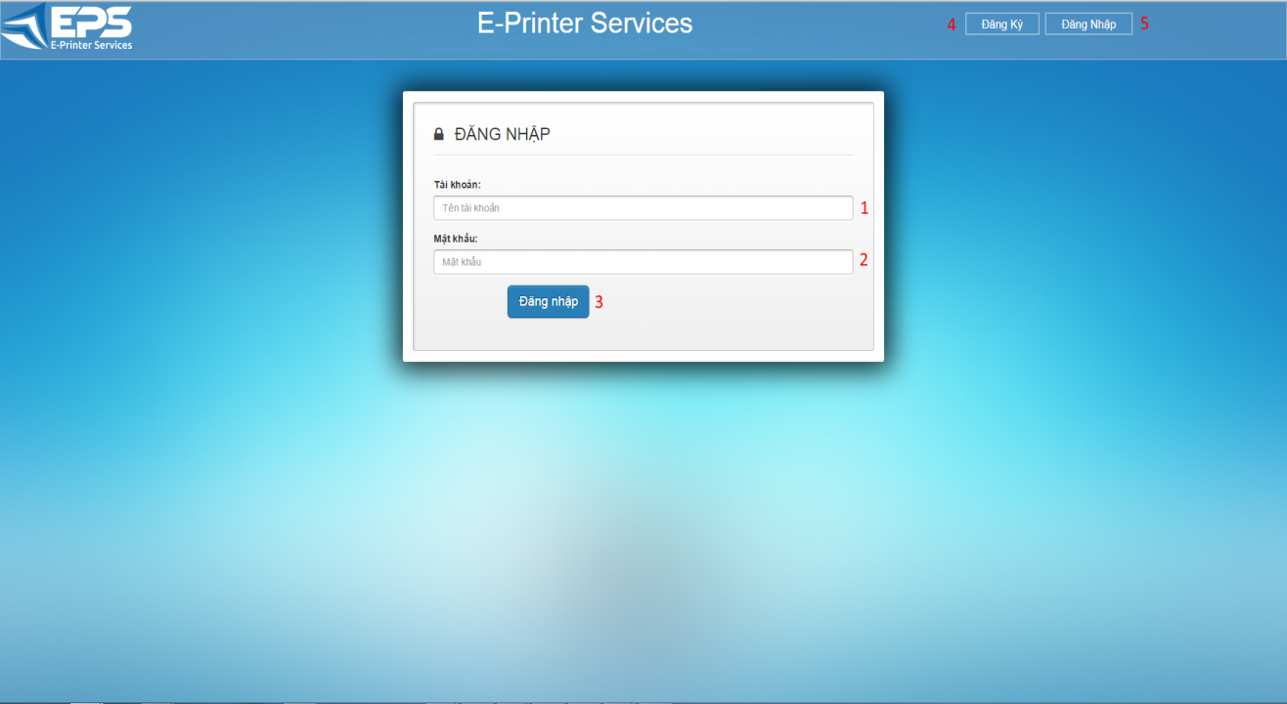**

**Figure 6: Storeowner Login**

**Fields**

|  |  |  |  |  |  |  |  |
| --- | --- | --- | --- | --- | --- | --- | --- |
| **No** | **Field Name** | **Description** | **Read only** | **Mandatory** | **Control Type** | **Data Type** | **Length** |
| 1 | Username | Fill user name | No | Yes | Textbox | String | N/A |
| 2 | Password | Fill password | No | Yes | Password | String | N/A |

**Buttons/Hyperlinks**

|  |  |  |  |  |
| --- | --- | --- | --- | --- |
| **No** | **Function** | **Description** | **Validation** | **Outcome** |
| 3 | Sign in | Log-in into the system | N/A | Transfer to storeowner home page |
| 4 | Register | Click to go to register page | N/A | Transfer to register page |
| 5 | Sign in | Click to go to login page | N/A | Transfer to login page |

#### Storeowner Home Page

**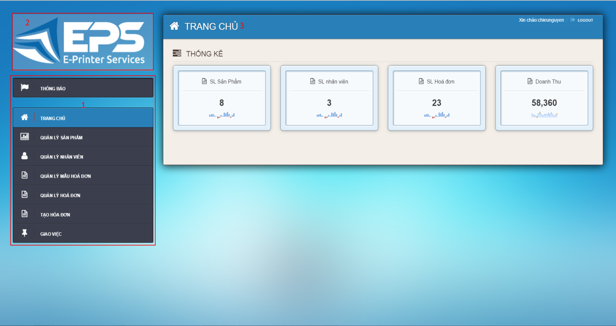**

**Figure 7: Storeowner Home Page**

**Fields**

|  |  |  |  |  |  |  |  |
| --- | --- | --- | --- | --- | --- | --- | --- |
| **No** | **Field Name** | **Description** | **Read only** | **Mandatory** | **Control Type** | **Data Type** | **Length** |
| 1 | Menu | Navigation bar | No | No | Menu bar | N/A | N/A |
| 2 | Logo | Logo of the system | Yes | No | Image | Image | N/A |
| 3 | Title | Title of the page | Yes | Yes | Label | String | N/A |

#### Notification

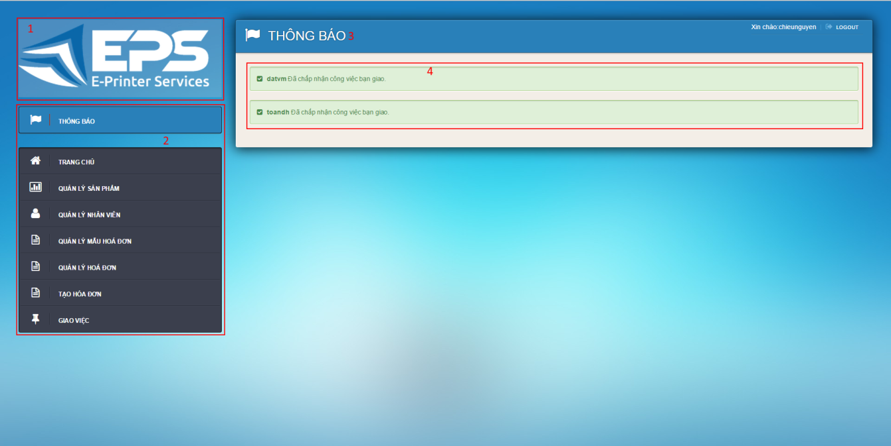

**Figure 8: Notification**

**Fields**

|  |  |  |  |  |  |  |  |
| --- | --- | --- | --- | --- | --- | --- | --- |
| **No** | **Field Name** | **Description** | **Read only** | **Mandatory** | **Control Type** | **Data Type** | **Length** |
| 1 | Menu | Navigation bar | No | No | Menu bar | N/A | N/A |
| 2 | Logo | Logo of the system | Yes | No | Image | Image | N/A |
| 3 | Title | Title of the page | Yes | Yes | Label | String | N/A |
| 4 | Notification | Notification from employee | Yes | Yes | Label | String | N/A |

#### Manage Item

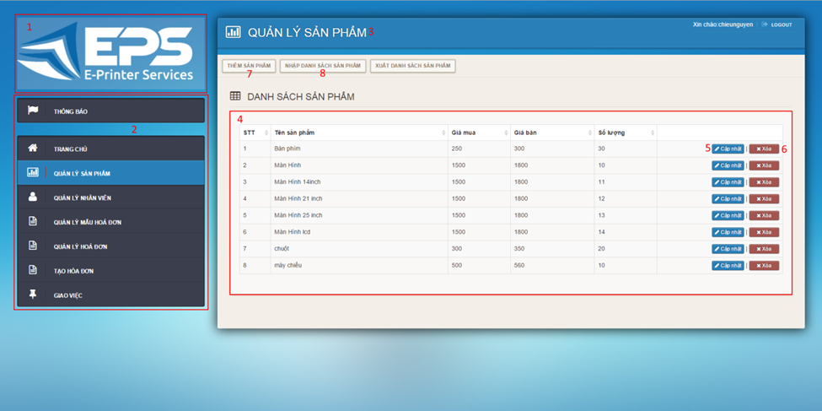

**Figure 9: Mange Items**

**Fields**

|  |  |  |  |  |  |  |  |
| --- | --- | --- | --- | --- | --- | --- | --- |
| **No** | **Field Name** | **Description** | **Read only** | **Mandatory** | **Control Type** | **Data Type** | **Length** |
| 1 | Logo | Logo of the system | Yes | No | Image | Image | N/A |
| 2 | Menu | Navigation bar | No | No | Menu bar | N/A | N/A |
| 3 | Title | Title of the page | Yes | Yes | Label | String | N/A |
| 4 | Item’s Table | Table to show items | Yes | Yes | Data Table | N/A | N/A |

**Buttons/Hyperlinks**

|  |  |  |  |  |
| --- | --- | --- | --- | --- |
| **No** | **Function** | **Description** | **Validation** | **Outcome** |
| 5 | Update | Click to go to update item page | N/A | Transfer to update item page |
| 6 | Delete | Delete an item | N/A | Transfer to manage item page |
| 7 | Add | Click to go to add item page | N/A | Transfer to add item page |
| 8 | Import Item | Click to go to import item page |  | Transfer to import item page |

#### Add Item

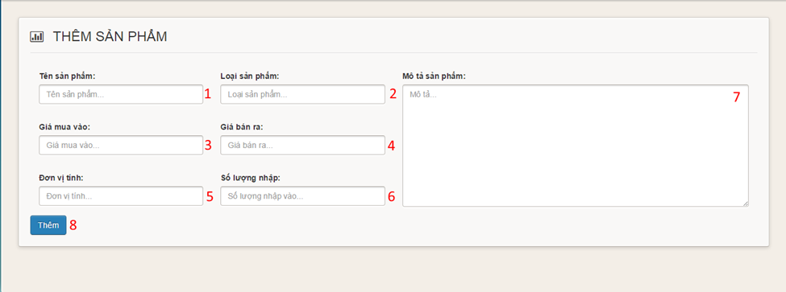

**Figure 10: Add Item**

**Fields**

|  |  |  |  |  |  |  |  |
| --- | --- | --- | --- | --- | --- | --- | --- |
| **No** | **Field Name** | **Description** | **Read only** | **Mandatory** | **Control Type** | **Data Type** | **Length** |
| 1 | Item name | Fill Item name | No | Yes | Textbox | String | N/A |
| 2 | Item type | Fill item type | No | Yes | Textbox | String | N/A |
| 3 | Supply price | Fill supply price | No | Yes | Textbox | String | N/A |
| 4 | Retail price | Fill retail price | No | Yes | Textbox | String | N/A |
| 5 | Item unit | Fill item unit | No | Yes | Textbox | String | N/A |
| 6 | Item quantity | Fill item quantity | No | Yes | Textbox | String | N/A |
| 7 | Description | Fill description | No | Yes | Text area | String | N/A |

**Buttons/Hyperlinks**

|  |  |  |  |  |
| --- | --- | --- | --- | --- |
| **No** | **Function** | **Description** | **Validation** | **Outcome** |
| 8 | Add | Click to add item | N/A | Transfer to manage item page |

#### Import Item

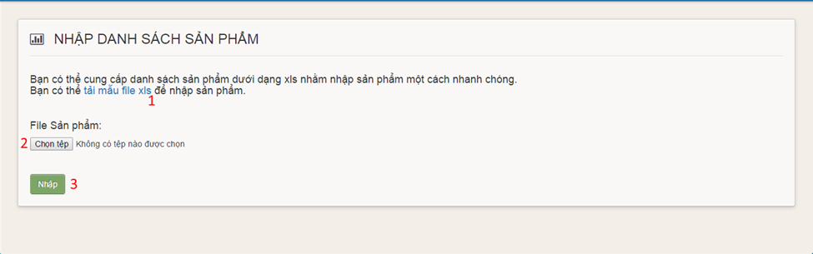

**Figure 11: Import Item**

**Buttons/Hyperlinks**

|  |  |  |  |  |
| --- | --- | --- | --- | --- |
| **No** | **Function** | **Description** | **Validation** | **Outcome** |
| 1 | Item template link | Click to download item template | N/A | Download item template |
| 2 | Choose file | Click to open choose file dialog | N/A | Display choose file dialog |
| 3 | Upload | Click to upload items | N/A | Transfer to manage items page |

#### Update Item

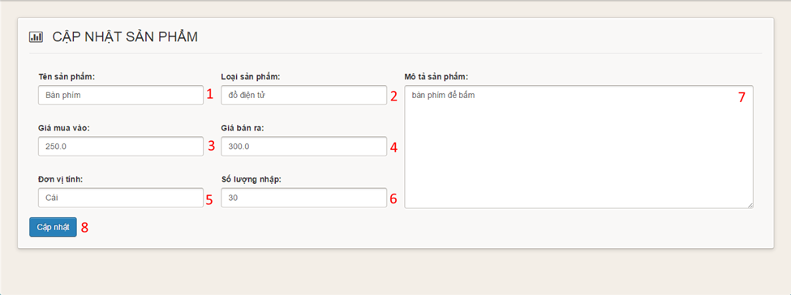

**Figure 12: Update Item**

**Fields**

|  |  |  |  |  |  |  |  |
| --- | --- | --- | --- | --- | --- | --- | --- |
| **No** | **Field Name** | **Description** | **Read only** | **Mandatory** | **Control Type** | **Data Type** | **Length** |
| 1 | Item name | Fill Item name | No | Yes | Textbox | String | N/A |
| 2 | Item type | Fill item type | No | Yes | Textbox | String | N/A |
| 3 | Supply price | Fill supply price | No | Yes | Textbox | String | N/A |
| 4 | Retail price | Fill retail price | No | Yes | Textbox | String | N/A |
| 5 | Item unit | Fill item unit | No | Yes | Textbox | String | N/A |
| 6 | Item quantity | Fill item quantity | No | Yes | Textbox | String | N/A |
| 7 | Description | Fill description | No | Yes | Text area | String | N/A |

**Buttons/Hyperlinks**

|  |  |  |  |  |
| --- | --- | --- | --- | --- |
| **No** | **Function** | **Description** | **Validation** | **Outcome** |
| 8 | Add | Click to update item | N/A | Transfer to manage item page |

#### Manage Employee

**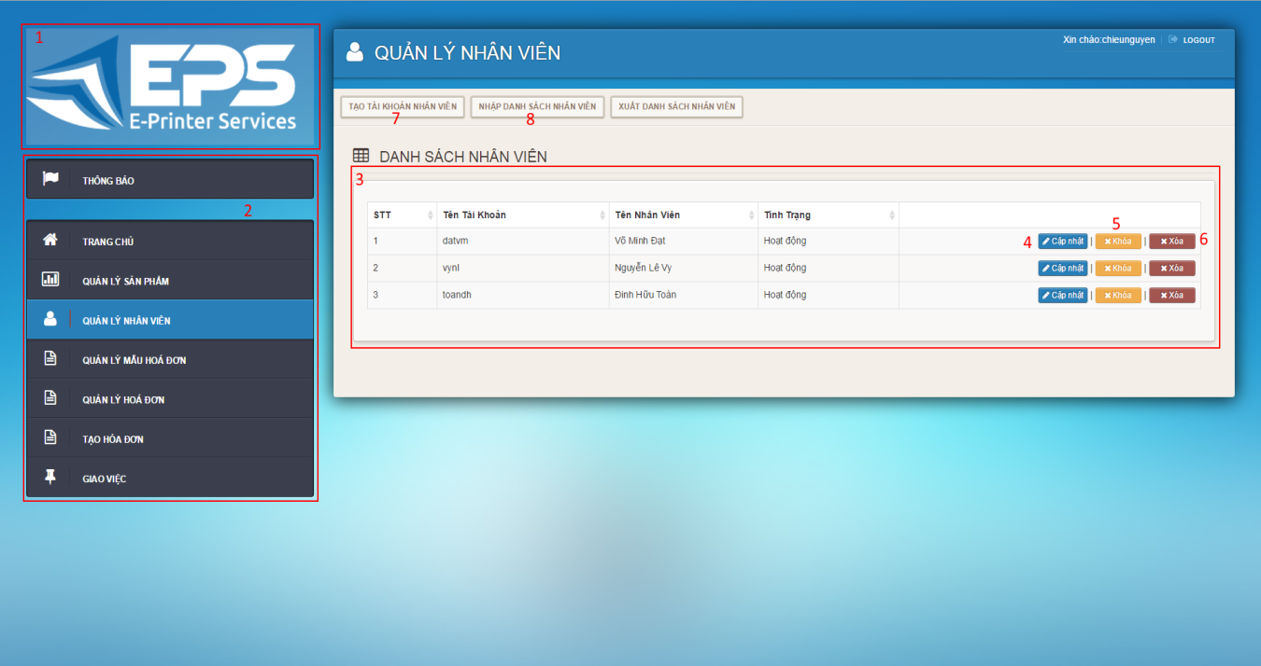Figure 13: Manage Employees**

**Fields**

|  |  |  |  |  |  |  |  |
| --- | --- | --- | --- | --- | --- | --- | --- |
| **No** | **Field Name** | **Description** | **Read only** | **Mandatory** | **Control Type** | **Data Type** | **Length** |
| 1 | Logo | Logo of the system | Yes | No | Image | Image | N/A |
| 2 | Menu | Navigation bar | No | No | Menu bar | N/A | N/A |
| 3 | Employee’s Table | Table to show employees | Yes | Yes | Data Table | N/A | N/A |

**Buttons/Hyperlinks**

|  |  |  |  |  |
| --- | --- | --- | --- | --- |
| **No** | **Function** | **Description** | **Validation** | **Outcome** |
| 4 | Update | Click to go to update employee page | N/A | Transfer to update employees page |
| 5 | Lock | Click to lock employee | N/A | Transfer to manage employees page |
| 6 | Delete | Delete an employee | N/A | Transfer to manage employees page |
| 7 | Add | Click to go to add employee page | N/A | Transfer to add employees page |
| 8 | Import Employees | Click to go to import employee page | N/A | Transfer to import employees page |

#### Add Employee

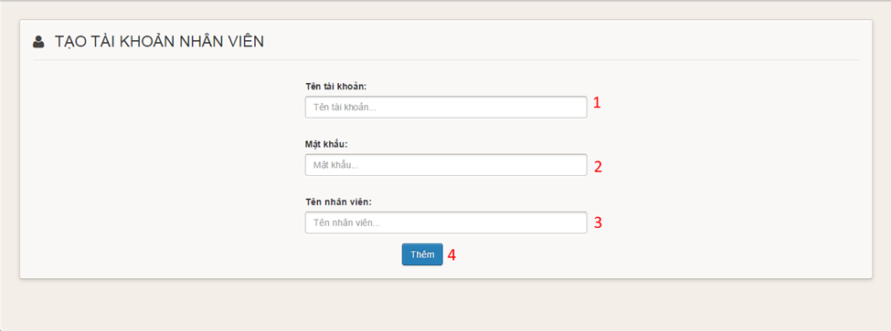

**Figure 14: Add Employee**

**Fields**

|  |  |  |  |  |  |  |  |
| --- | --- | --- | --- | --- | --- | --- | --- |
| **No** | **Field Name** | **Description** | **Read only** | **Mandatory** | **Control Type** | **Data Type** | **Length** |
| 1 | Username | Fill employee username | No | Yes | Textbox | String | N/A |
| 2 | Password | Fill employee password | No | Yes | Password | String | N/A |
| 3 | Full name | Fill employee full name | No | No | Textbox | String | N/A |

**Buttons/Hyperlinks**

|  |  |  |  |  |
| --- | --- | --- | --- | --- |
| **No** | **Function** | **Description** | **Validation** | **Outcome** |
| 4 | Add | Click to add employee | N/A | Transfer to manage employee page |

#### Import Employee

**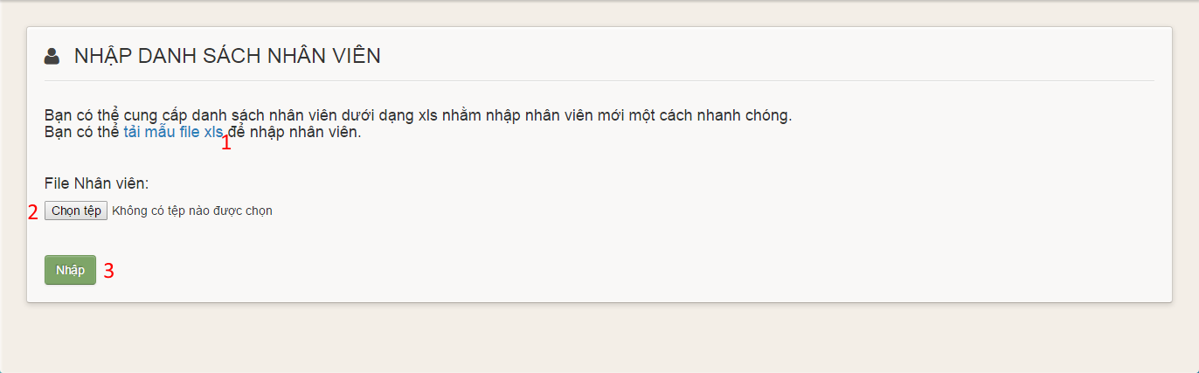Figure 15: Import Employee**

**Buttons/Hyperlinks**

|  |  |  |  |  |
| --- | --- | --- | --- | --- |
| **No** | **Function** | **Description** | **Validation** | **Outcome** |
| 1 | Employee template link | Click to download employee template | N/A | Download employee template |
| 2 | Choose file | Click to open choose file dialog | N/A | Display choose file dialog |
| 3 | Upload | Click to upload employees | N/A | Transfer to manage employees page |

#### Update Employee

**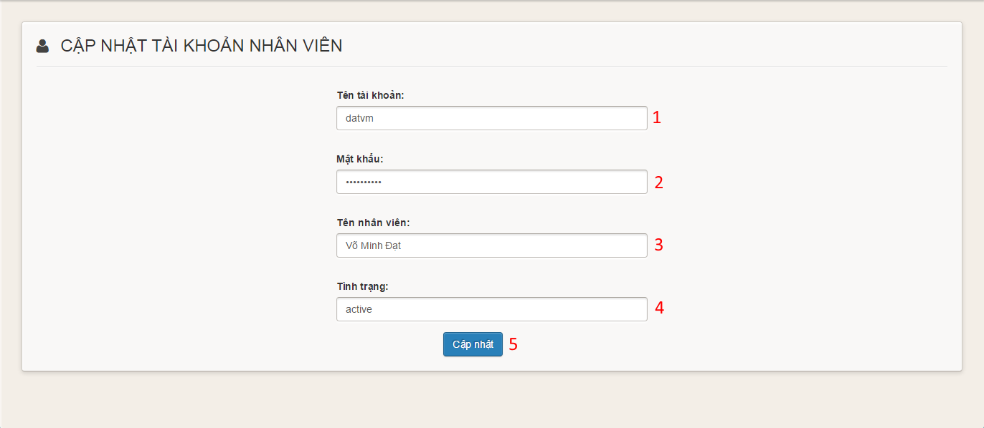**

**Figure 16: Update Employee**

**Fields**

|  |  |  |  |  |  |  |  |
| --- | --- | --- | --- | --- | --- | --- | --- |
| **No** | **Field Name** | **Description** | **Read only** | **Mandatory** | **Control Type** | **Data Type** | **Length** |
| 1 | Username | Fill employee username | No | Yes | Textbox | String | N/A |
| 2 | Password | Fill employee password | No | Yes | Password | String | N/A |
| 3 | Full name | Fill employee full name | No | No | Textbox | String | N/A |
| 4 | Status | Fill employee status | No | Yes | Combobox | String | N/A |

**Buttons/Hyperlinks**

|  |  |  |  |  |
| --- | --- | --- | --- | --- |
| **No** | **Function** | **Description** | **Validation** | **Outcome** |
| 5 | Add | Click to update employee | N/A | Transfer to manage employee page |

#### Storeowner Manage Templates

**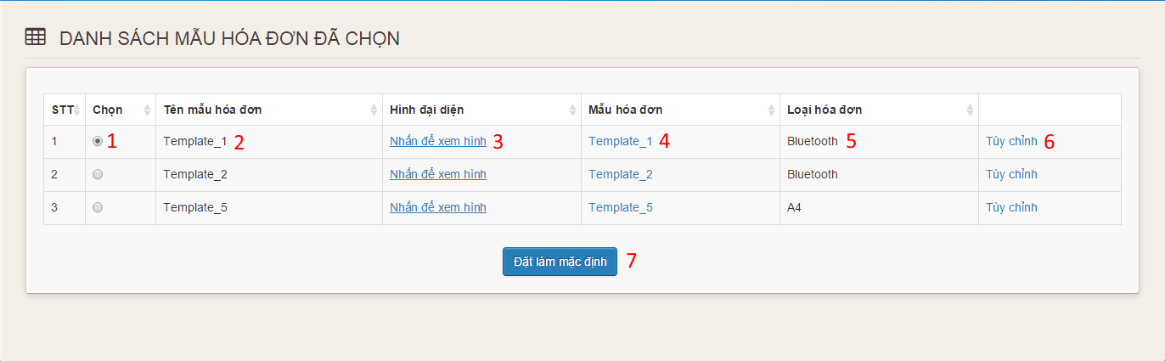**

**Figure 17: Storeowner Manage Templates**

**Fields**

|  |  |  |  |  |  |  |  |
| --- | --- | --- | --- | --- | --- | --- | --- |
| **No** | **Field Name** | **Description** | **Read only** | **Mandatory** | **Control Type** | **Data Type** | **Length** |
| 1 | Choose | Choose default template | No | Yes | Radiobutton | N/A | N/A |
| 2 | Template Name | Display name of template | Yes | Yes | Label | String | N/A |
| 3 | Image link | Click to view image | No | Yes | Link | String | N/A |
| 4 | Template link | Click to download template | No | Yes | Link | String | N/A |
| 5 | Type | Display type of template | Yes | Yes | Label | String | N/A |
| 6 | Customize | Click to go to customize page | No | Yes | Link | String | N/A |

**Buttons/Hyperlinks**

|  |  |  |  |  |
| --- | --- | --- | --- | --- |
| **No** | **Function** | **Description** | **Validation** | **Outcome** |
| 7 | Set Default | Click to set default template | N/A | Transfer to manage template page |

#### Customize Bluetooth Template

**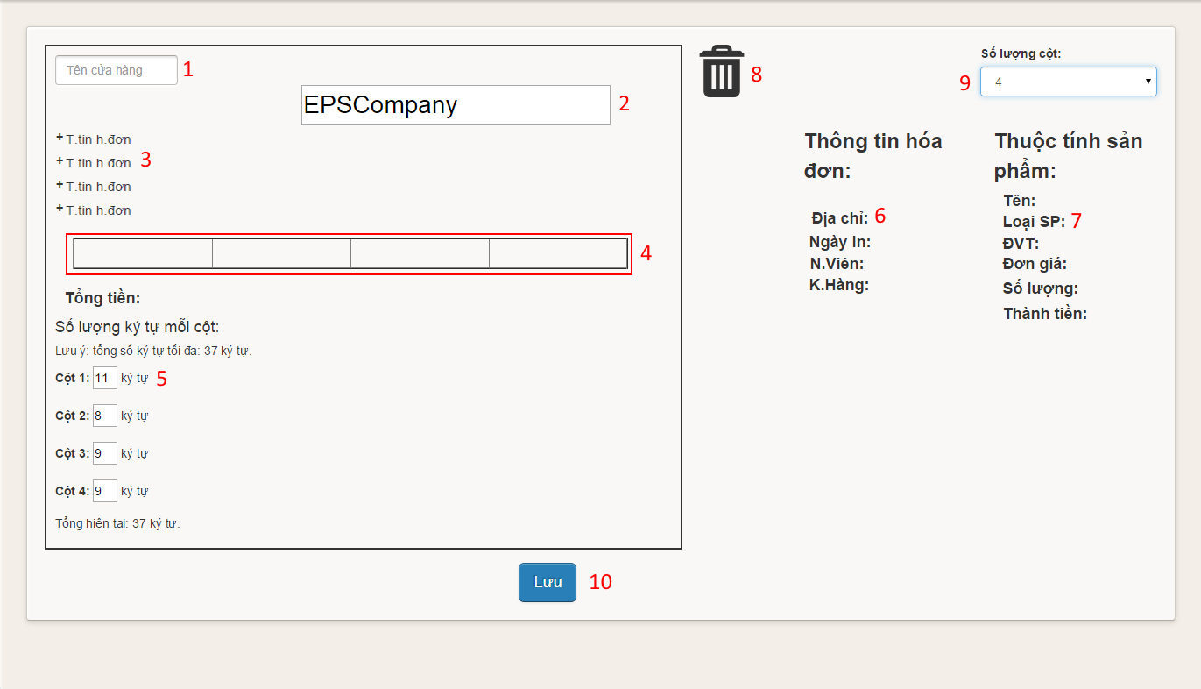**

**Figure 18: Customize Bluetooth Template**

**Fields**

|  |  |  |  |  |  |  |  |
| --- | --- | --- | --- | --- | --- | --- | --- |
| **No** | **Field Name** | **Description** | **Read only** | **Mandatory** | **Control Type** | **Data Type** | **Length** |
| 1 | Store Name | Fill store name | No | Yes | Textbox | String | N/A |
| 2 | Template Title | Fill template title | No | Yes | Textbox | String | N/A |
| 3 | Order Information Position | Fill order information | Yes | Yes | Label | String | N/A |
| 4 | Item Information Position | Fill item information | Yes | Yes | Table | N/A | N/A |
| 5 | Columns limit characters | Fill limit characters | No | Yes | Textbox | String | 2 |
| 6 | Order Information | Order Information | Yes | Yes | Image | Image | N/A |
| 7 | Item Information | Item Information | Yes | Yes | Image | Image | N/A |
| 8 | Trash | To remove information | Yes | Yes | Image | Image | N/A |
| 9 | Number Of Columns | Fill number of columns | No | Yes | Combobox | String | N/A |

**Buttons/Hyperlinks**

|  |  |  |  |  |
| --- | --- | --- | --- | --- |
| **No** | **Function** | **Description** | **Validation** | **Outcome** |
| 10 | Save | Click to customize template | N/A | Transfer to manage template page |

#### Customize A4 Template

**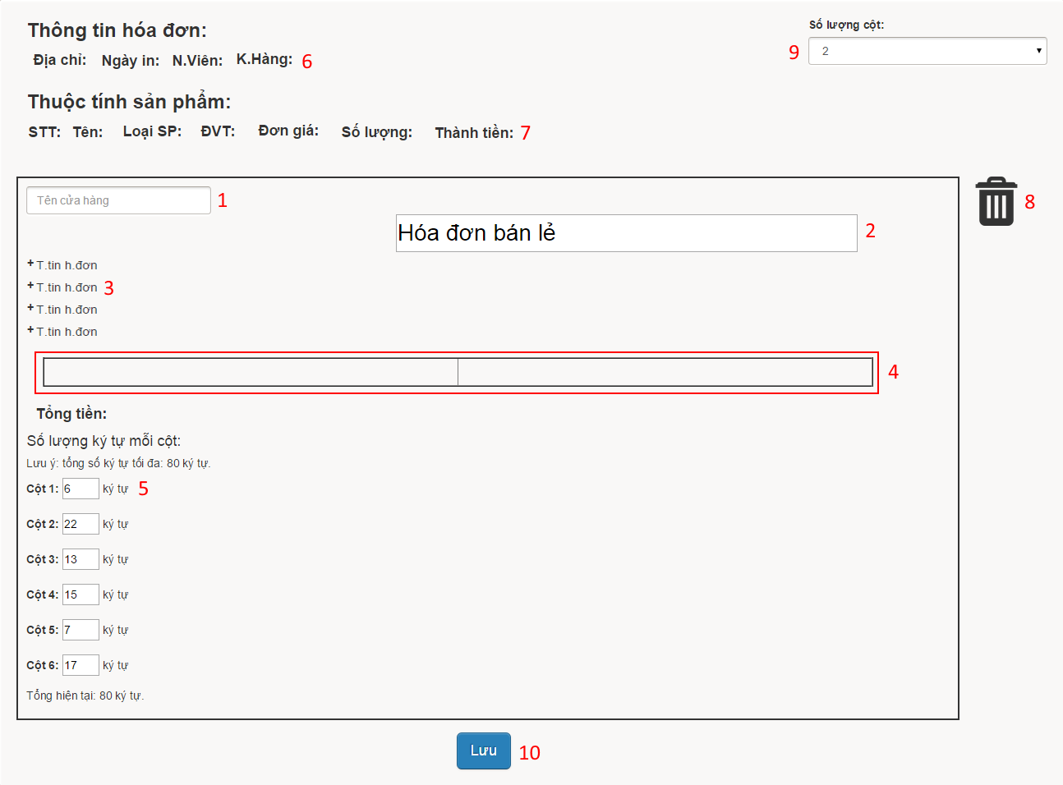**

**Figure 19: Customize A4 Template**

**Fields**

|  |  |  |  |  |  |  |  |
| --- | --- | --- | --- | --- | --- | --- | --- |
| **No** | **Field Name** | **Description** | **Read only** | **Mandatory** | **Control Type** | **Data Type** | **Length** |
| 1 | Store Name | Fill store name | No | Yes | Textbox | String | N/A |
| 2 | Template Title | Fill template title | No | Yes | Textbox | String | N/A |
| 3 | Order Information Position | Fill order information | Yes | Yes | Label | String | N/A |
| 4 | Item Information Position | Fill item information | Yes | Yes | Table | N/A | N/A |
| 5 | Columns limit characters | Fill limit characters | No | Yes | Textbox | String | 2 |
| 6 | Order Information | Order Information | Yes | Yes | Image | Image | N/A |
| 7 | Item Information | Item Information | Yes | Yes | Image | Image | N/A |
| 8 | Trash | To remove information | Yes | Yes | Image | Image | N/A |
| 9 | Number Of Columns | Fill number of columns | No | Yes | Combobox | String | N/A |

**Buttons/Hyperlinks**

|  |  |  |  |  |
| --- | --- | --- | --- | --- |
| **No** | **Function** | **Description** | **Validation** | **Outcome** |
| 10 | Save | Click to customize template | N/A | Transfer to manage template page |

#### Manage Order

**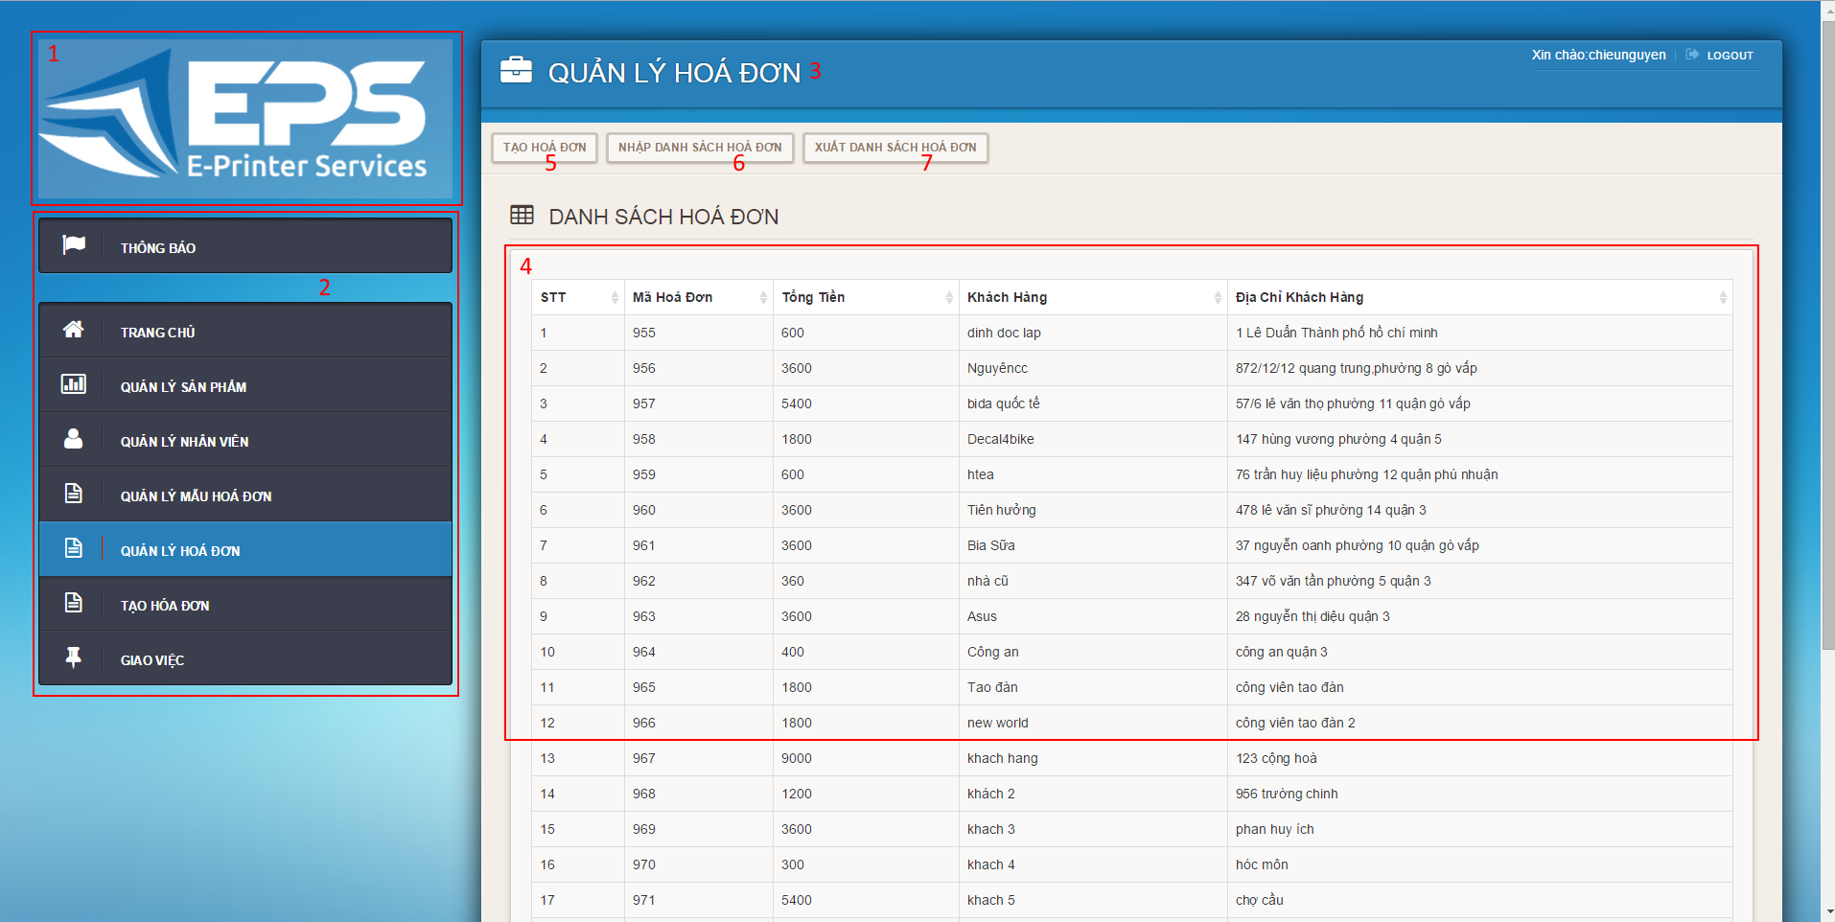**

**Figure 20: Manage Orders**

**Fields**

|  |  |  |  |  |  |  |  |
| --- | --- | --- | --- | --- | --- | --- | --- |
| **No** | **Field Name** | **Description** | **Read only** | **Mandatory** | **Control Type** | **Data Type** | **Length** |
| 1 | Logo | Logo of the system | Yes | No | Image | Image | N/A |
| 2 | Menu | Navigation bar | No | No | Menu bar | N/A | N/A |
| 3 | Title | Title of the page | Yes | Yes | Label | N/A | N/A |
| 4 | Order’s Table | Table to show orders | Yes | Yes | Data Table | N/A | N/A |

**Buttons/Hyperlinks**

|  |  |  |  |  |
| --- | --- | --- | --- | --- |
| **No** | **Function** | **Description** | **Validation** | **Outcome** |
| 5 | Create | Click to go to create order page | N/A | Transfer to create order page |
| 6 | Import | Click to go to import order page | N/A | Transfer to import order page |
| 7 | Export | Click to go to export order page | N/A | Transfer to export order page |

#### Create Order

##### C:\Users\NguyenCCSE60911\Desktop\CP Sreen Shot\CreateOrder1.pngCreate Order step 1

**Figure 21: Create Order step 1**

**Fields**

|  |  |  |  |  |  |  |  |
| --- | --- | --- | --- | --- | --- | --- | --- |
| **No** | **Field Name** | **Description** | **Read only** | **Mandatory** | **Control Type** | **Data Type** | **Length** |
| 1 | Choose Template | Click to choose template | No | Yes | Combobox | String | N/A |

**Buttons/Hyperlinks**

|  |  |  |  |  |
| --- | --- | --- | --- | --- |
| **No** | **Function** | **Description** | **Validation** | **Outcome** |
| 2 | Continue | Click to go to create order step 2 | N/A | Display create order step 2 |

##### Create Order step 2

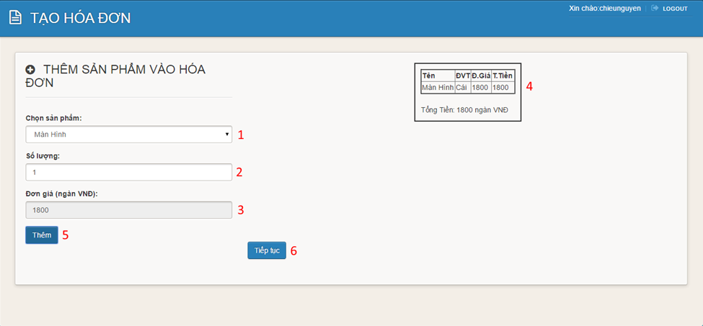

**Figure 22: Create Order step 2**

**Fields**

|  |  |  |  |  |  |  |  |
| --- | --- | --- | --- | --- | --- | --- | --- |
| **No** | **Field Name** | **Description** | **Read only** | **Mandatory** | **Control Type** | **Data Type** | **Length** |
| 1 | Choose Item | Click to item template | No | Yes | Combobox | String | N/A |
| 2 | Quantity | Fill quantity of item | No | Yes | Textbox | String | N/A |
| 3 | Price | Display price of item | Yes | Yes | Textbox | String | N/A |
| 4 | Order | Display order | Yes | Yes | Image | Image | N/A |

**Buttons/Hyperlinks**

|  |  |  |  |  |
| --- | --- | --- | --- | --- |
| **No** | **Function** | **Description** | **Validation** | **Outcome** |
| 5 | Add | Click to add item to order | N/A | Add item to order |
| 6 | Continue | Click to go to create order step 3 | N/A | Display create order step 3 |

##### Create Order step 3

**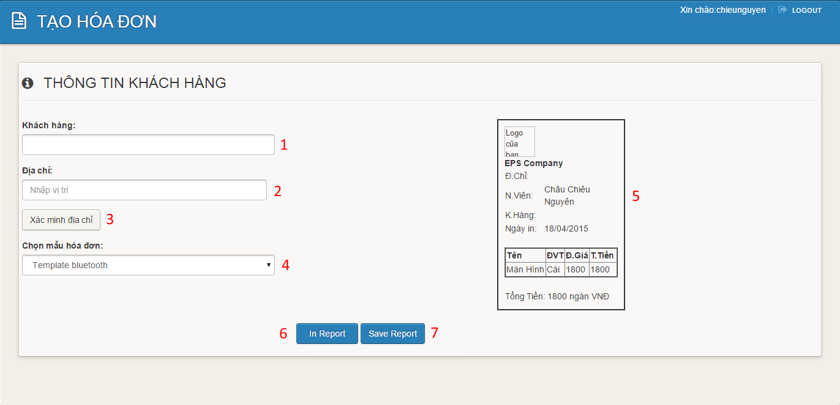Figure 23: Create Order step 3**

**Fields**

|  |  |  |  |  |  |  |  |
| --- | --- | --- | --- | --- | --- | --- | --- |
| **No** | **Field Name** | **Description** | **Read only** | **Mandatory** | **Control Type** | **Data Type** | **Length** |
| 1 | Customer Name | Fill customer name | No | Yes | Textbox | String | N/A |
| 2 | Address | Fill address of customer | No | Yes | Textbox | String | N/A |
| 4 | Choose Template | Click to choose template | No | Yes | Combobox | String | N/A |
| 5 | Order | Display order | Yes | Yes | Image | Image | N/A |

**Buttons/Hyperlinks**

|  |  |  |  |  |
| --- | --- | --- | --- | --- |
| **No** | **Function** | **Description** | **Validation** | **Outcome** |
| 3 | Confirm Address | Click to go to confirm address page | N/A | Transfer to confirm address page |
| 6 | Print | Click to go to print order page | N/A | Display print order page |
| 7 | Save | Click to save order | N/A | Transfer to manage order page |

#### Import Orders

**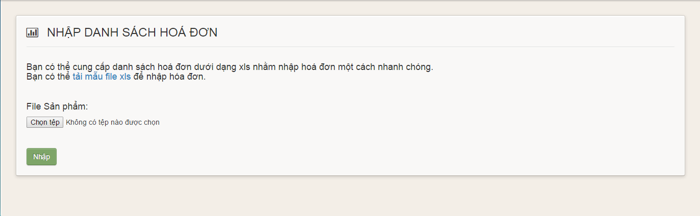Figure 24: Import Orders**

**Buttons/Hyperlinks**

|  |  |  |  |  |
| --- | --- | --- | --- | --- |
| **No** | **Function** | **Description** | **Validation** | **Outcome** |
| 1 | Order template link | Click to download order template | N/A | Download order template |
| 2 | Choose file | Click to open choose file dialog | N/A | Display choose file dialog |
| 3 | Upload | Click to upload orders | N/A | Transfer to manage orders page |

#### Assign Order

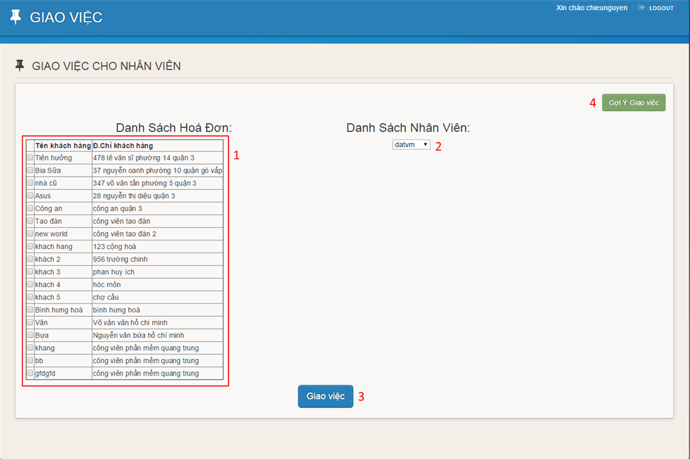

**Figure 25: Assign Order**

**Fields**

|  |  |  |  |  |  |  |  |
| --- | --- | --- | --- | --- | --- | --- | --- |
| **No** | **Field Name** | **Description** | **Read only** | **Mandatory** | **Control Type** | **Data Type** | **Length** |
| 1 | Order Table | Display orders | Yes | Yes | Data Table | N/A | N/A |
| 2 | Choose Employee | Click to choose employee | Yes | Yes | Combobox | String | N/A |

**Buttons/Hyperlinks**

|  |  |  |  |  |
| --- | --- | --- | --- | --- |
| **No** | **Function** | **Description** | **Validation** | **Outcome** |
| 3 | Assign Order | Click to assign order to employee | N/A | Transfer to storeowner home page |
| 4 | Suggest | Click to suggest assigning order | N/A | Transfer to suggesting page. |

#### Choose Template

**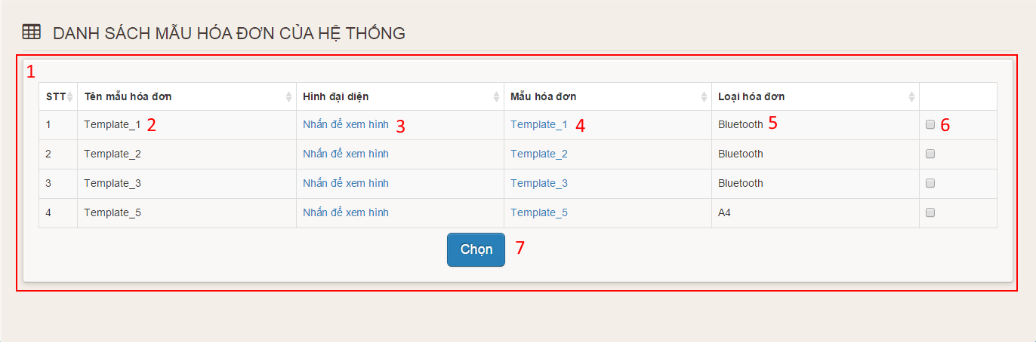**

**Figure 26: Choose Template**

**Fields**

|  |  |  |  |  |  |  |  |
| --- | --- | --- | --- | --- | --- | --- | --- |
| **No** | **Field Name** | **Description** | **Read only** | **Mandatory** | **Control Type** | **Data Type** | **Length** |
| 1 | Template Table | Display templates of the system | Yes | Yes | Data Table | N/A | N/A |
| 2 | Template Name | Display name of template | Yes | Yes | Label | String | N/A |
| 3 | Image link | Click to view image | No | Yes | Link | String | N/A |
| 4 | Template link | Click to download template | No | Yes | Link | String | N/A |
| 5 | Type | Display type of template | Yes | Yes | Label | String | N/A |
| 6 | Choose | Click choose template | No | Yes | Checkbox | N/A | N/A |

**Buttons/Hyperlinks**

|  |  |  |  |  |
| --- | --- | --- | --- | --- |
| **No** | **Function** | **Description** | **Validation** | **Outcome** |
| 7 | Choose | Click to choose template | N/A | Transfer to manage template page |

### Employee Interface Design

#### Login screen

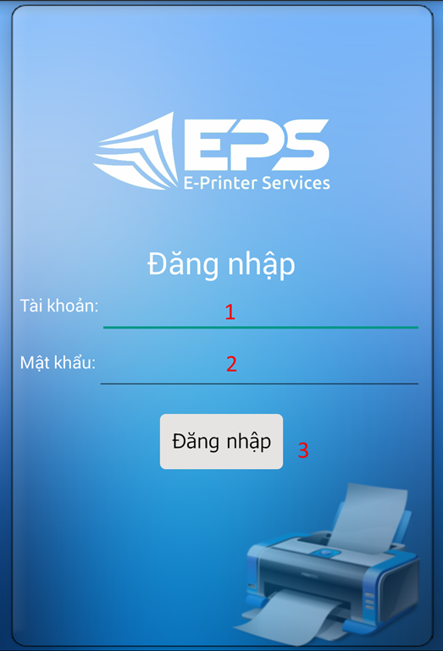

**Figure 27: Mobile Login**

**Fields**

|  |  |  |  |  |  |  |  |
| --- | --- | --- | --- | --- | --- | --- | --- |
| **No** | **Field Name** | **Description** | **Read only** | **Mandatory** | **Control Type** | **Data Type** | **Length** |
| 1 | Username | Fill username | No | Yes | Textbox | String | N/A |
| 2 | Password | Fill password | No | Yes | Password | String | N/A |

**Buttons/Hyperlinks**

|  |  |  |  |  |
| --- | --- | --- | --- | --- |
| **No** | **Function** | **Description** | **Validation** | **Outcome** |
| 3 | Sign in | Log-in into the Android application | N/A | Transfer to menu screen |

#### Menu screen

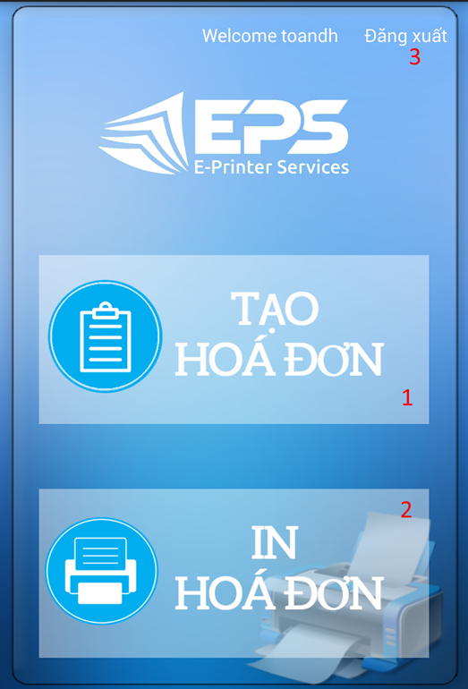

**Figure 28: Mobile Menu**

**Buttons/Hyperlinks**

|  |  |  |  |  |
| --- | --- | --- | --- | --- |
| **No** | **Function** | **Description** | **Validation** | **Outcome** |
| 1 | Create order | Touch to go to create order screen | N/A | Transfer to create order screen |
| 2 | Print order | Touch to go to view order screen | N/A | Transfer to view order screen |
| 3 | Logout link | Touch to logout | N/A | Transfer to login screen |

#### Create Order

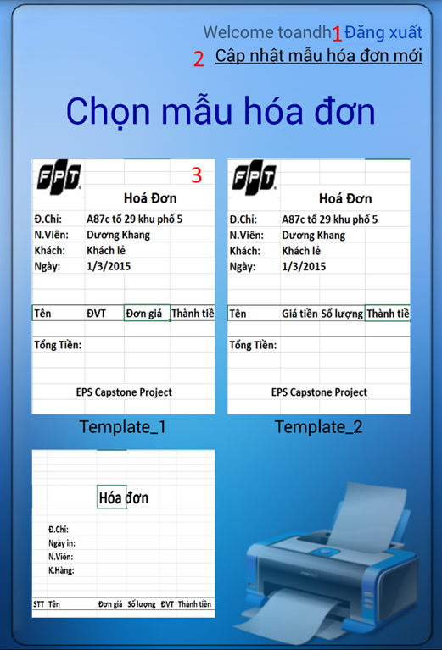

**Figure 29: Create Order**

**Buttons/Hyperlinks**

|  |  |  |  |  |
| --- | --- | --- | --- | --- |
| **No** | **Function** | **Description** | **Validation** | **Outcome** |
| 1 | Logout link | Touch to logout | N/A | Transfer to login screen |
| 2 | Update templates link | Touch to update templates | N/A | Display new templates |
| 3 | Image of template | Touch to choose template | N/A | Transfer to input item screen |

#### Input Item Screen

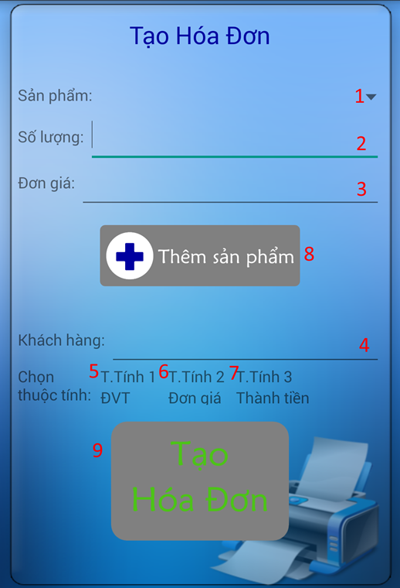

**Figure 30: Input Item**

**Fields**

|  |  |  |  |  |  |  |  |
| --- | --- | --- | --- | --- | --- | --- | --- |
| **No** | **Field Name** | **Description** | **Read only** | **Mandatory** | **Control Type** | **Data Type** | **Length** |
| 1 | Item | Choose item | No | Yes | Combo box | String | N/A |
| 2 | Quantity | Fill quantity | No | Yes | Textbox | String | N/A |
| 3 | Price | Display price | Yes | Yes | Textbox | String | N/A |
| 4 | Customer name | Fill customer name | No | No | Textbox | String | N/A |

**Buttons/Hyperlinks**

|  |  |  |  |  |
| --- | --- | --- | --- | --- |
| **No** | **Function** | **Description** | **Validation** | **Outcome** |
| 5 | Attribute 1 | Touch to choose attribute 1 | N/A | Display attribute 1 |
| 6 | Attribute 2 | Touch to choose attribute 2 | N/A | Display attribute 2 |
| 7 | Attribute 3 | Touch to choose attribute 3 | N/A | Display attribute 3 |
| 8 | Add item | Touch to add item to order | N/A | Display message “Đã thêm”. |
| 9 | Create order | Touch to create order | N/A | Transfer to view order screen |

#### View Order screen

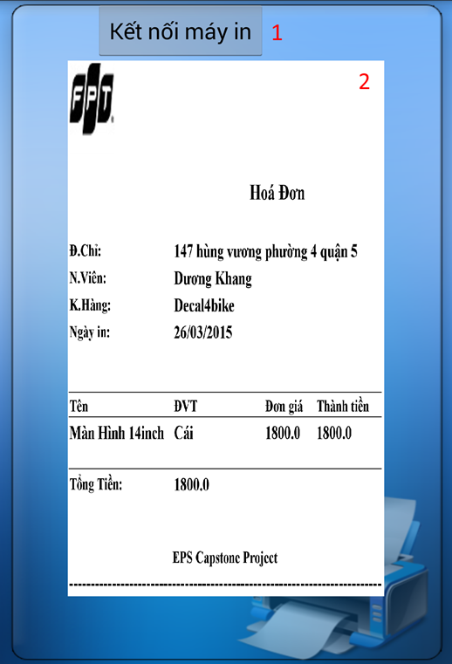

**Figure 31: View Order**

**Fields**

|  |  |  |  |  |  |  |  |
| --- | --- | --- | --- | --- | --- | --- | --- |
| **No** | **Field Name** | **Description** | **Read only** | **Mandatory** | **Control Type** | **Data Type** | **Length** |
| 2 | Order Image | Display order image | Yes | Yes | Image | Image | N/A |

**Buttons/Hyperlinks**

|  |  |  |  |  |
| --- | --- | --- | --- | --- |
| **No** | **Function** | **Description** | **Validation** | **Outcome** |
| 1 | Connect Printer | Touch to connect to printer | N/A | Transfer to search printer screen. |

#### Search Printer

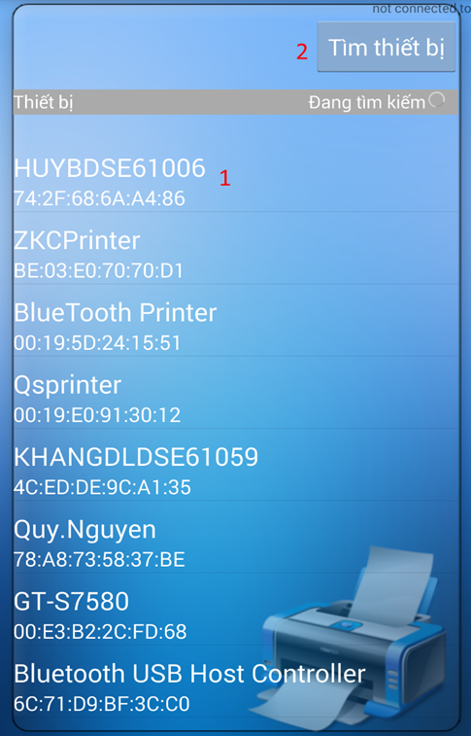

**Figure 32: Search Printer**

**Buttons/Hyperlinks**

|  |  |  |  |  |
| --- | --- | --- | --- | --- |
| **No** | **Function** | **Description** | **Validation** | **Outcome** |
| 1 | Printer | Touch to connect to printer | N/A | Transfer to print screen. |
| 2 | Search | Touch to search printer | N/A | Display list of printer |

#### Print Order

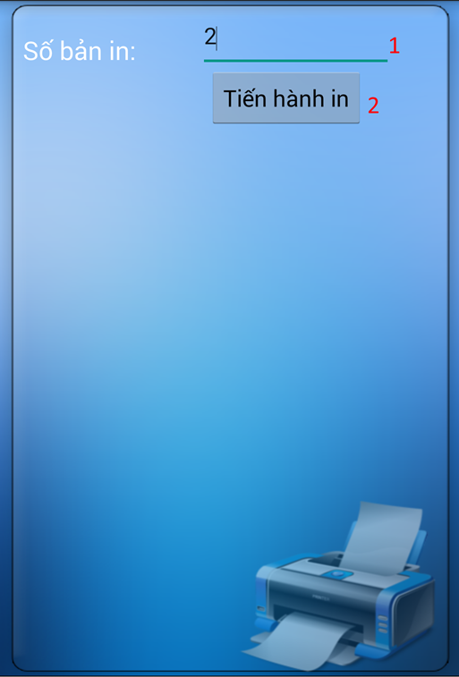

**Figure 33: Print Order**

**Fields**

|  |  |  |  |  |  |  |  |
| --- | --- | --- | --- | --- | --- | --- | --- |
| **No** | **Field Name** | **Description** | **Read only** | **Mandatory** | **Control Type** | **Data Type** | **Length** |
| 1 | Number of copies | Fill number of copies | No | Yes | Textbox | Number | N/A |

**Buttons/Hyperlinks**

|  |  |  |  |  |
| --- | --- | --- | --- | --- |
| **No** | **Function** | **Description** | **Validation** | **Outcome** |
| 2 | Print | Touch to print order | N/A | N/A |

#### View Order Information

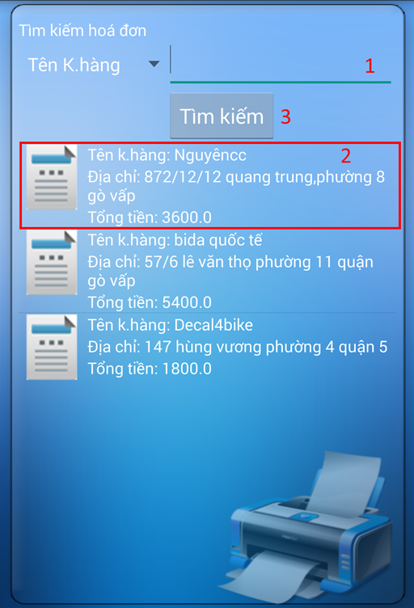

**Figure 34: View Order Information**

**Fields**

|  |  |  |  |  |  |  |  |
| --- | --- | --- | --- | --- | --- | --- | --- |
| **No** | **Field Name** | **Description** | **Read only** | **Mandatory** | **Control Type** | **Data Type** | **Length** |
| 1 | Customer name | Fill keywords to search | No | Yes | Textbox | String | N/A |

**Buttons/Hyperlinks**

|  |  |  |  |  |
| --- | --- | --- | --- | --- |
| **No** | **Function** | **Description** | **Validation** | **Outcome** |
| 2 | Order link | Touch to choose order | N/A | Transfer to choose template screen |
| 3 | Search | Touch to search order based on customer name | N/A | Display order |

#### Choose Template

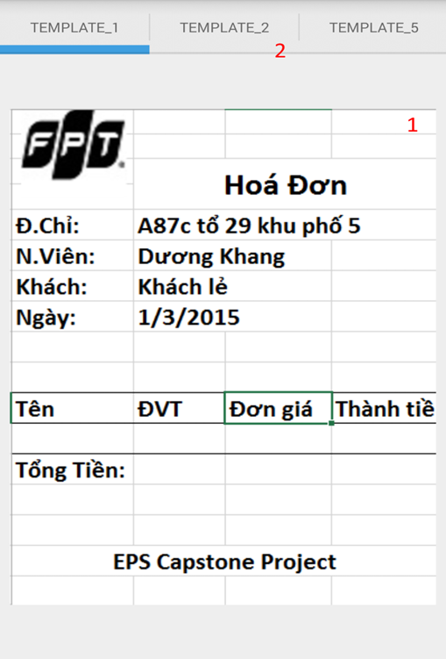

**Figure 35: Choose Template**

**Fields**

|  |  |  |  |  |  |  |  |
| --- | --- | --- | --- | --- | --- | --- | --- |
| **No** | **Field Name** | **Description** | **Read only** | **Mandatory** | **Control Type** | **Data Type** | **Length** |
| 1 | Menu | Display name of template | Yes | Yes | Menu | N/A | N/A |

**Buttons/Hyperlinks**

|  |  |  |  |  |
| --- | --- | --- | --- | --- |
| **No** | **Function** | **Description** | **Validation** | **Outcome** |
| 2 | Template Image | Touch to choose template | N/A | Transfer to view order screen |

## Database Design

### Logical Diagram

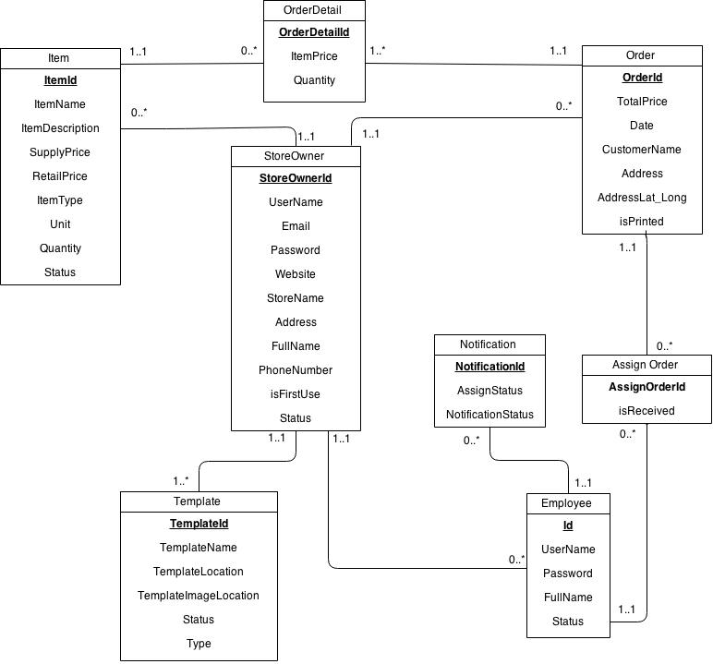

Figure 51: Logical Diagram

### Data Dictionary

|  |  |
| --- | --- |
| **Entity Data dictionary: describe content of all entities** | |
| Entity Name | Description |
| Items | Describe all Items in the system. |
| Store Owner | Describe all StoreOwners in the system. |
| Template | Describe all Templates available in the system. |
| Employee | Describe all Employees in the system. |
| Order | Describe all Order in the system. |
| Order Detail | Describe all Order Details in the system. |
| Notification | Describe all Notifications in the system. |
| Assign Order | Describe all templates available in the system. |

Table 1: Entity Data Dictionary

|  |  |  |  |  |
| --- | --- | --- | --- | --- |
| **Entity name** | **Attributes** | **Description** | **Domain** | **Null** |
| Store Owner | StoreOwnerId | Unique identifier of StoreOwner, auto increment. | int | No |
| UserName | StoreOwner’s username. | nvarchar(50) | No |
| Email | StoreOwner’s email address. | nvarchar(50) | No |
| Password | StoreOwner’s password. | nvarchar(50) | No |
| Website | StoreOwner’s website address. | nvarchar(50) | Yes |
| StoreName | Name of the store. | nvarchar(50) | No |
| Address | The address of StoreOwner. | nvarchar(100) | No |
| FullName | Full name of StoreOwner. | nvarchar(100) | No |
| PhoneNumber | Phone number of StoreOwner. | int | No |
| isFirstUse | Value to check whether StoreOwner log in for the first time or not. | bit | No |
| Status | Status of StoreOwner. | nchar(10) | No |
| Employee | Id | Unique identifier of employee, auto increment. | int | No |
| UserName | Employee’s username. | nchar(20) | No |
| Password | Employee’s password. | nchar(10) | No |
| FullName | Employee’s full name. | nvarchar(50) | Yes |
| Status | Status of employee. | nchar(20) | No |
| Item | ItemId | Unique identifier of item, auto increment. | int | No |
| ItemName | Name of an item. | nvarchar(100) | No |
| ItemDescription | Description about an item. | nvarchar(500) | Yes |
| SupplyPrice | Supply price of item. | float | No |
| RetailPrice | Retail price of item. | float | No |
| ItemType | Type of item. | nvarchar(50) | No |
| Unit | Unit of an item. | nvarchar(50) | No |
| Quantity | Quantity of item in store. | int | No |
| Status | Status of an item. | nchar(10) | No |
| Template | TemplateId | Unique identifier of template, auto increment. | int | No |
| TemplateName | Name of template. | nvarchar(50) | No |
| TemplateLocation | Location of template on server. | nvarchar(260) | No |
| TemplateImageLocation | Location of image template on server. | nvarchar(260) | No |
| Status | Status of template. | nvarchar(20) | No |
| Type | Type of template. | nchar(10) | No |
| Order | OrderId | Unique identifier of order, auto increment. | int | No |
| TotalPrice | Total price of order. | float | No |
| Date | Date order made. | datetime | No |
| CustomerName | Name of the customer. | nvarchar(30) | No |
| Address | Address of customer. | nvarchar(100) | No |
| AddressLat\_Long | Latitude and longitude of address. | varchar(100) | No |
| isPrinted | Value to check whether the order is printed or not. | bit | No |
| OrderDetail | OrderDetailId | Unique identifier of orderdetail, auto increment. | int | No |
| ItemPrice | Price of an item in orderdetail. | float | No |
| Quantity | Quantity of items in order. | int | No |
| Notification | NotificationId | Unique identifier of notification, auto increment. | int | No |
| AssignStatus | Status of job assigned to employee | bit | No |
| NotificationStatus | Status of notification | bit | No |
| AssignOrder | AssignOrderId | Unique identifier of AssignOrder,auto increment | bit | No |
| isReceived | Status of each assign order | bit | No |

Table 2: Detail Data Dictionary

\* Business integrity constraint:

- StoreOwner only can access to their items, employees and orders.

## Algorithms

### Basic model color and mat in openCV

#### The basic model color of image:

##### RGB color image:

The RGB color model is an additive color model in which red, green, and blue light are added together in various ways to reproduce a broad array of colors. The name of the model comes from the initials of the three additive primary colors, red, green, and blue.

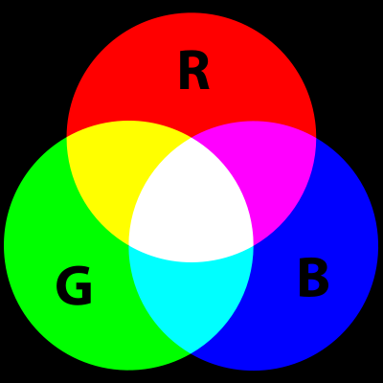

Nowaday, the RGB color model used very popular in television, computer screen, mobile devices.

* + - * 1. **History of RGB color model:**

The RGB color model is developed by **Thomas Young** and **Hermann Helmholtz** in the early to mid nineteenth century, and on **James Clerk Maxwell'**s color triangle that elaborated that theory (circa 1860).

The first experiments’s Maxwell about RGB color model were made in 1861. He involved the process of combining three color-filtered separate takes. To reproduce the color photograph, three matching projections over a screen in a dark room were necessary.

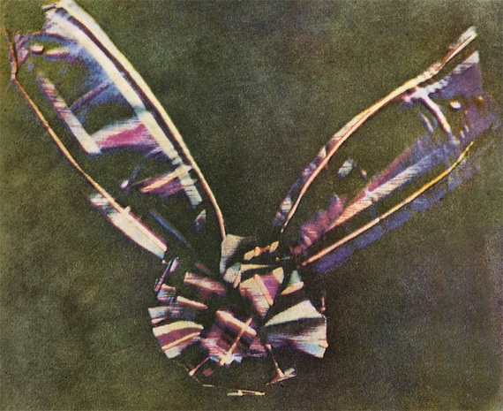

Before the development of practical electronic TV, there were patents on mechanically scanned color systems as early as 1889 in Russia. The color TV pioneer John Logie Baird demonstrated the world's first RGB color transmission in 1928, and also the world's first color broadcast in 1938, in London. In his experiments, scanning and display were done mechanically by spinning colorized wheels. The Columbia Broadcasting System (CBS) began an experimental RGB field-sequential color system in 1940. Images were scanned electrically, but the system still used a moving part: the transparent RGB color wheel rotating at above 1,200 rpm in synchronism with the vertical scan. The camera and the cathode-ray tube (CRT) were both monochromatic. Color was provided by color wheels in the camera and the receiver. More recently, color wheels have been used in field-sequential projection TV receivers based on the Texas Instruments monochrome DLP imager.The modern RGB shadow mask technology for color CRT displays was patented by Werner Flechsig in Germany in 1938.

Early personal computers of the late 1970s and early 1980s, such as those from Apple, Atari and Commodore, did not use RGB as their main method to manage colors, but rather composite video. IBM introduced a 16-color scheme (four bits—one bit each for red, green, blue, and intensity) with the Color Graphics Adapter (CGA) for its first IBM PC (1981), later improved with the Enhanced Graphics Adapter (EGA) in 1984. The first manufacturer of a truecolor graphic card for PCs (the TARGA) was Truevision in 1987, but it was not until the arrival of the Video Graphics Array (VGA) in 1987 that RGB became popular, mainly due to the analog signals in the connection between the adapter and the monitor which allowed a very wide range of RGB colors. Actually, it had to wait a few more years because the original VGA cards were palette-driven just like EGA, although with more freedom than VGA, but because the VGA connectors were analogue, later variants of VGA (made by various manufacturers under the informal name Super VGA) eventually added truecolor. In 1992, magazines heavily advertised truecolor Super VGA hardware.

#### RGB devices:

**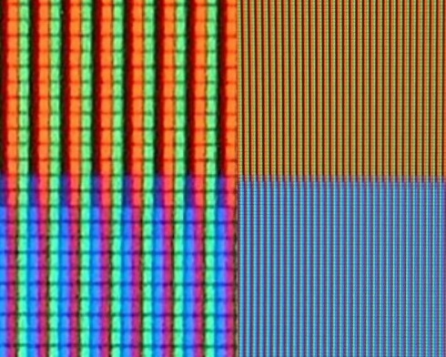**

RGB sub-pixels in an LCD TV

RGB color model can show image with a color in nature so, RGB color model used very popular in television, computer screen, mobile device.

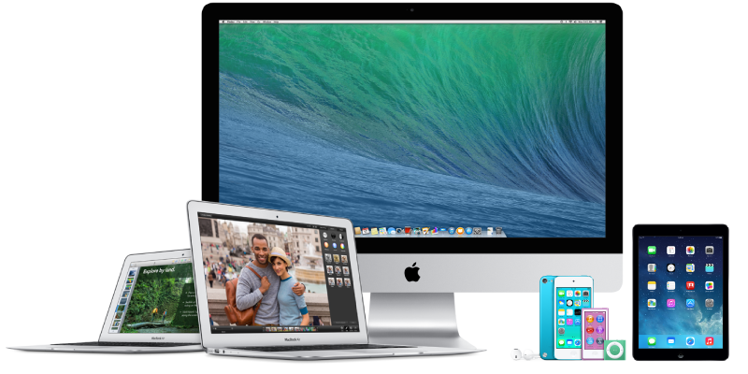

##### Grayscale

Grayscale digital image is an image in which the value of each pixel is a single sample, that is, it carries only intensity information. Images of this sort, also known as black-and-white, are composed exclusively of shades of gray, varying from black at the weakest intensity to white at the strongest.

Grayscale images are often the result of measuring the intensity of light at each pixel in a single band of the electromagnetic spectrum (e.g. infrared, visible light, ultraviolet, etc.), and in such cases they are monochromatic proper when only a given frequency is captured. But also they can be synthesized from a full color image; see the section about converting to grayscale.

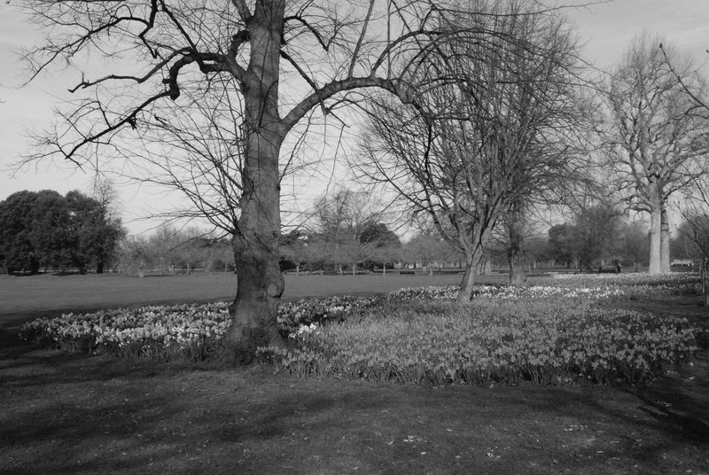

Nowaday, in computing, we have 2 type of grayscale is 8 bits of each pixel (255 levels) and 16 bits of each pixel (65,535 levels).

##### Binary color model:

A binary image is a digital image that has only two possible values for each pixel. Typically the two colors used for a binary image are black and white though any two colors can be used.

So, what is difference between grayscale and binary image?

Black and White image contains only two levels. Gray image represent by black and white shades or combination of levels for e.g 8 bit gray image means total 28 - 1 = 255 levels form black to white.

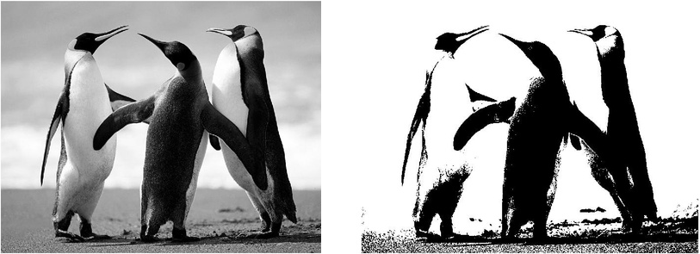

##### LAB color model:

The 'Lab' colour space is one of the least used image formats as no print production, picture library, or website would ever consider using it. And yet, ironically, everyone does. 'Lab' covers all potential colours, every colour that the human eye is able to see. As such it is an absolute and therefore is not colour managed as there are no degrees of 'Lab' for a colour profile to describe. Because of this Photoshop uses it as its native colour space. So every time an image is converted from RGB to CMYK, or back again, it is passed through 'Lab' in the process.

**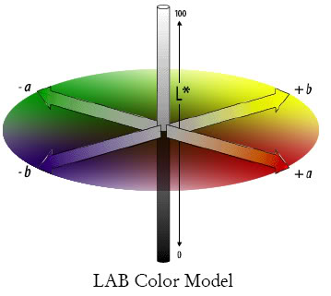**

In LAB mode, the sample is represented by a combination of three channels:

* L (lightness - Luminance): Channel L is the vertical axis, shows the brightness of color, with a value of 0 (black) to 100 (White). This channel is solely contains information about brightness, color does not contain real value.
* Channel "a": Contains the value of color from Green (-) to the Red (+).
* Channel "b": Contains the value of color from Blue (-) to Yellow (+).

#### Mat in OpenCV:

Mat in OpenCV is a class with an n-dimensional dense numerical single-channel or multi-channel array.

|  |  |
| --- | --- |
| **Parameters:** | * **ndims** – Array dimensionality. * **rows** – Number of rows in a 2D array. * **cols** – Number of columns in a 2D array. * **roi** – Region of interest. * **size** – 2D array size: Size(cols, rows) . In the Size() constructor, the number of rows and the number of columns go in the reverse order. * **sizes** – Array of integers specifying an n-dimensional array shape. * **type** – Array type. Use CV\_8UC1, ..., CV\_64FC4 to create 1-4 channel matrices, or CV\_8UC(n), ..., CV\_64FC(n) to create multi-channel (up to CV\_CN\_MAX channels) matrices. * **s** – An optional value to initialize each matrix element with. To set all the matrix elements to the particular value after the construction, use the assignment operator Mat::operator=(const Scalar& value) . * **data** – Pointer to the user data. Matrix constructors that take data and step parameters do not allocate matrix data. Instead, they just initialize the matrix header that points to the specified data, which means that no data is copied. This operation is very efficient and can be used to process external data using OpenCV functions. The external data is not automatically deallocated, so you should take care of it. * **step** – Number of bytes each matrix row occupies. The value should include the padding bytes at the end of each row, if any. If the parameter is missing (set to AUTO\_STEP ), no padding is assumed and the actual step is calculated as cols\*elemSize(). * **steps** – Array of ndims-1 steps in case of a multi-dimensional array (the last step is always set to the element size). If not specified, the matrix is assumed to be continuous. * **m** – Array that (as a whole or partly) is assigned to the constructed matrix. No data is copied by these constructors. Instead, the header pointing to m data or its sub-array is constructed and associated with it. The reference counter, if any, is incremented. So, when you modify the matrix formed using such a constructor, you also modify the corresponding elements of m . If you want to have an independent copy of the sub-array, use Mat::clone() . * **img** – Pointer to the old-style IplImage image structure. By default, the data is shared between the original image and the new matrix. But when copyData is set, the full copy of the image data is created. * **vec** – STL vector whose elements form the matrix. The matrix has a single column and the number of rows equal to the number of vector elements. Type of the matrix matches the type of vector elements. The constructor can handle arbitrary types, for which there is a properly declared [DataType](http://docs.opencv.org/modules/core/doc/basic_structures.html#DataType) . This means that the vector elements must be primitive numbers or uni-type numerical tuples of numbers. Mixed-type structures are not supported. The corresponding constructor is explicit. Since STL vectors are not automatically converted to Mat instances, you should write Mat(vec) explicitly. Unless you copy the data into the matrix ( copyData=true ), no new elements will be added to the vector because it can potentially yield vector data reallocation, and, thus, the matrix data pointer will be invalid. * **copyData** – Flag to specify whether the underlying data of the STL vector or the old-style CvMat or IplImage should be copied to (true) or shared with (false) the newly constructed matrix. When the data is copied, the allocated buffer is managed using Mat reference counting mechanism. While the data is shared, the reference counter is NULL, and you should not deallocate the data until the matrix is not destructed. * **rowRange** – Range of the m rows to take. As usual, the range start is inclusive and the range end is exclusive. Use Range::all() to take all the rows. * **colRange** – Range of the m columns to take. Use Range::all() to take all the columns. * **ranges** – Array of selected ranges of m along each dimensionality. |

Parameters “**type**” decided on the type of data stored by image.4

A Mapping of Type to Numbers in OpenCV

|  |  |  |  |  |  |
| --- | --- | --- | --- | --- | --- |
|  |  | C1 | C2 | C3 | C4 |
| CV\_8U |  | 0 | 8 | 16 | 24 |
| CV\_8S |  | 1 | 9 | 17 | 25 |
| CV\_16U |  | 2 | 10 | 18 | 26 |
| CV\_16S |  | 3 | 11 | 19 | 27 |
| CV\_32S |  | 4 | 12 | 20 | 28 |
| CV\_32F |  | 5 | 13 | 21 | 29 |
| CV\_64F |  | 6 | 14 | 22 | 30 |

The naming sheme for the types is CV\_<bit-depth>{U|S|F}C<number\_of\_channels>.

EX:

* CV\_8UC4 translates to: four channels of unsigned char

CV\_16S translates to: 1 channel of signed 2-byte integer.

### Cvtcolor method and convert a gray image to a binary image

#### cvtColor method

Converts an image from one color space to another.

**C++:** void cvtColor(InputArray **src**, OutputArray **dst**, int **code**, int **dstCn**=0 )

|  |  |
| --- | --- |
| **Parameters:** | * **src** – input image: 8-bit unsigned, 16-bit unsigned ( CV\_16UC... ), or single-precision floating-point. * **dst** – output image of the same size and depth as src. * **code** – color space conversion code (see the description below). * **dstCn** – number of channels in the destination image; if the parameter is 0, the number of the channels is derived automatically from src and code . |

The function converts an input image from one color space to another. In case of a transformation to-from RGB color space, the order of the channels should be specified explicitly (RGB or BGR). Note that the default color format in OpenCV is often referred to as RGB but it is actually BGR (the bytes are reversed). So the first byte in a standard (24-bit) color image will be an 8-bit Blue component, the second byte will be Green, and the third byte will be Red. The fourth, fifth, and sixth bytes would then be the second pixel (Blue, then Green, then Red), and so on.

The conventional ranges for R, G, and B channel values are:

* 0 to 255 for CV\_8U images
* 0 to 65535 for CV\_16U images
* 0 to 1 for CV\_32F images

In case of linear transformations, the range does not matter. But in case of a non-linear transformation, an input RGB image should be normalized to the proper value range to get the correct results, for example, for RGB L\*u\*v\* transformation. For example, if you have a 32-bit floating-point image directly converted from an 8-bit image without any scaling, then it will have the 0..255 value range instead of 0..1 assumed by the function. So, before calling cvtColor , you need first to scale the image down:

img \*= 1./255;

cvtColor(img, img, CV\_BGR2Luv);

If you use cvtColor with 8-bit images, the conversion will have some information lost. For many applications, this will not be noticeable but it is recommended to use 32-bit images in applications that need the full range of colors or that convert an image before an operation and then convert back.

If conversion adds the alpha channel, its value will set to the maximum of corresponding channel range: 255 for CV\_8U, 65535 for CV\_16U, 1 for CV\_32F.

The function can do the following transformations:

* RGB GRAY ( CV\_BGR2GRAY, CV\_RGB2GRAY, CV\_GRAY2BGR, CV\_GRAY2RGB ) Transformations within RGB space like adding/removing the alpha channel, reversing the channel order, conversion to/from 16-bit RGB color (R5:G6:B5 or R5:G5:B5), as well as conversion to/from grayscale using:



and



The conversion from a RGB image to gray is done with:

cvtColor(src, bwsrc, CV\_RGB2GRAY);

More advanced channel reordering can also be done with [mixChannels()](http://docs.opencv.org/modules/core/doc/operations_on_arrays.html#void mixChannels(const Mat* src, size_t nsrcs, Mat* dst, size_t ndsts, const int* fromTo, size_t npairs)) .

* RGB CIE XYZ.Rec 709 with D65 white point ( CV\_BGR2XYZ, CV\_RGB2XYZ, CV\_XYZ2BGR, CV\_XYZ2RGB ):

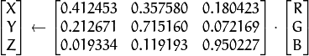

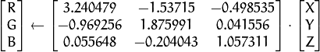

, and cover the whole value range (in case of floating-point images, may exceed 1).

* RGB YCrCb JPEG (or YCC) ( CV\_BGR2YCrCb, CV\_RGB2YCrCb, CV\_YCrCb2BGR, CV\_YCrCb2RGB )













where

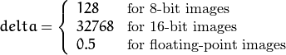

Y, Cr, and Cb cover the whole value range.

* RGB HSV ( CV\_BGR2HSV, CV\_RGB2HSV, CV\_HSV2BGR, CV\_HSV2RGB )

In case of 8-bit and 16-bit images, R, G, and B are converted to the floating-point format and scaled to fit the 0 to 1 range.



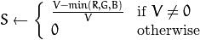

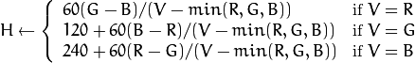

If then . On output , , .

The values are then converted to the destination data type:

* + 8-bit images



* + 16-bit images (currently not supported)



* + 32-bit images

H, S, and V are left as is

* RGB HLS ( CV\_BGR2HLS, CV\_RGB2HLS, CV\_HLS2BGR, CV\_HLS2RGB ).

In case of 8-bit and 16-bit images, R, G, and B are converted to the floating-point format and scaled to fit the 0 to 1 range.





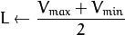

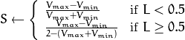

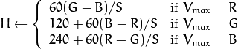

If then . On output , , .

The values are then converted to the destination data type:

* + 8-bit images



* + 16-bit images (currently not supported)



* + 32-bit images

H, S, V are left as is

* RGB CIE L\*a\*b\* ( CV\_BGR2Lab, CV\_RGB2Lab, CV\_Lab2BGR, CV\_Lab2RGB ).

In case of 8-bit and 16-bit images, R, G, and B are converted to the floating-point format and scaled to fit the 0 to 1 range.







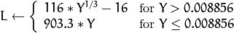





where

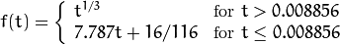

and

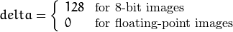

This outputs , , . The values are then converted to the destination data type:

* + 8-bit images



* + 16-bit images

(currently not supported)

* + 32-bit images

L, a, and b are left as is

* RGB CIE L\*u\*v\* ( CV\_BGR2Luv, CV\_RGB2Luv, CV\_Luv2BGR, CV\_Luv2RGB ).

In case of 8-bit and 16-bit images, R, G, and B are converted to the floating-point format and scaled to fit 0 to 1 range.



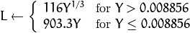









This outputs , , .

The values are then converted to the destination data type:

* + 8-bit images



* + 16-bit images

(currently not supported)

* + 32-bit images

L, u, and v are left as is

The above formulae for converting RGB to/from various color spaces have been taken from multiple sources on the web, primarily from the Charles Poynton site <http://www.poynton.com/ColorFAQ.html>

* Bayer RGB ( CV\_BayerBG2BGR, CV\_BayerGB2BGR, CV\_BayerRG2BGR, CV\_BayerGR2BGR, CV\_BayerBG2RGB, CV\_BayerGB2RGB, CV\_BayerRG2RGB, CV\_BayerGR2RGB ). The Bayer pattern is widely used in CCD and CMOS cameras. It enables you to get color pictures from a single plane where R,G, and B pixels (sensors of a particular component) are interleaved as follows:

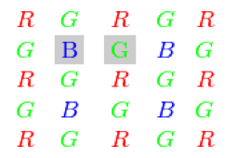

The output RGB components of a pixel are interpolated from 1, 2, or 4 neighbors of the pixel having the same color. There are several modifications of the above pattern that can be achieved by shifting the pattern one pixel left and/or one pixel up. The two letters and in the conversion constants CV\_Bayer 2BGR and CV\_Bayer 2RGB indicate the particular pattern type. These are components from the second row, second and third columns, respectively. For example, the above pattern has a very popular “BG” type.

**\* Code demo:**

How to use cvtColor in OpenCV

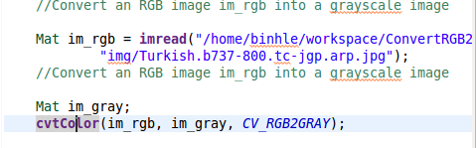

Result:

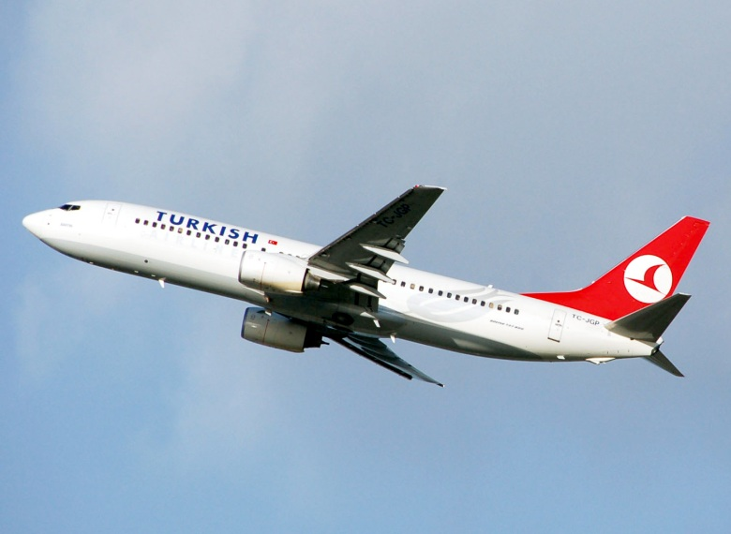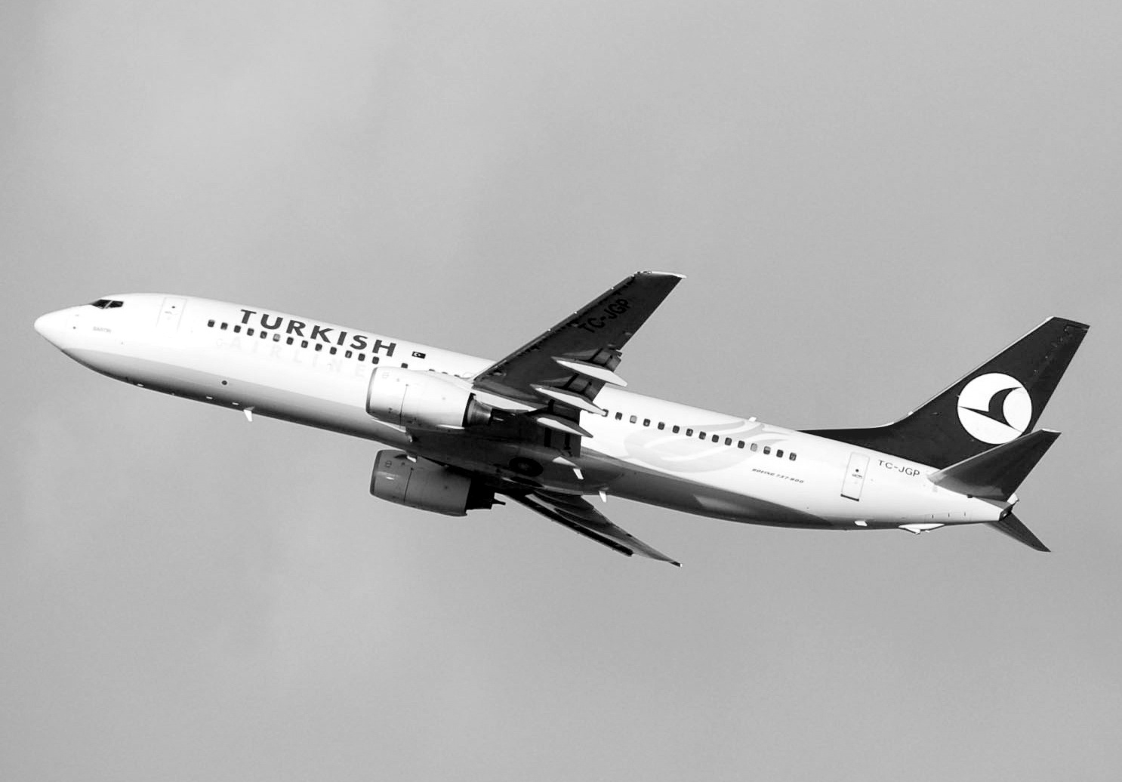

#### How to converts gray image to binage image

##### We can use “static threshold”:

- First, we can choose a gray image.

- After that, we choose a static threshold for this image.

**\* Advantage**

- This method is easy to use, easy to understand.

- Coding easy.

**\* Disadvantage**

- We choose a static threshold so we must focus about bright of image.

**\* Code demo:**

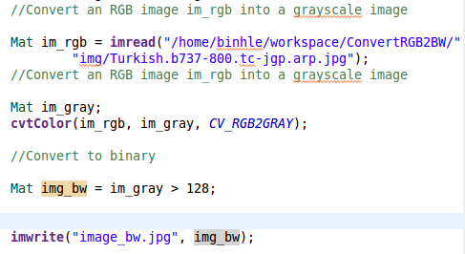

**\* Result**



##### We can use “Dymamic threshold” adaptiveThreshold method in OpenCV

This method will cut us gray image to small window. For example:

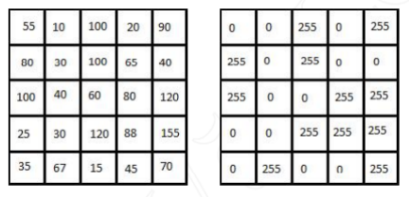

The binary image is obtained on the binary image with threshold is the avaerage of all the cells in window T = (55 +10 + 100 + …)/25 = 65.5.

**\* Advantage**

- Cannot focus about bright of image.

**\* Disadvantage**

- Must know about OpenCV and using adaptiveThreshold method.

**\* AdaptiveThreshold method:**

Applies an adaptive threshold to an array.

C++: void adaptiveThreshold(InputArray src, OutputArray dst, double maxValue, int adaptiveMethod, int thresholdType, int blockSize, double C)

|  |  |
| --- | --- |
| Parameters: | * src – Source 8-bit single-channel image. * dst – Destination image of the same size and the same type as src . * maxValue – Non-zero value assigned to the pixels for which the condition is satisfied. See the details below. * adaptiveMethod – Adaptive thresholding algorithm to use, ADAPTIVE\_THRESH\_MEAN\_C or ADAPTIVE\_THRESH\_GAUSSIAN\_C . See the details below. * thresholdType – Thresholding type that must be either THRESH\_BINARY or THRESH\_BINARY\_INV . * blockSize – Size of a pixel neighborhood that is used to calculate a threshold value for the pixel: 3, 5, 7, and so on. * C – Constant subtracted from the mean or weighted mean (see the details below). Normally, it is positive but may be zero or negative as well. |

The function transforms a grayscale image to a binary image according to the formulae:

* THRESH\_BINARY

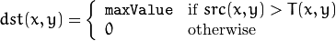

* THRESH\_BINARY\_INV

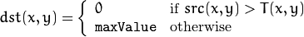

where  is a threshold calculated individually for each pixel.

* adaptiveMethod: 2 type is **ADAPTIVE\_THRESH\_MEAN\_C** and **ADAPTIVE\_THRESH\_GAUSSIAN\_C**
* **ADAPTIVE\_THRESH\_MEAN\_C :** threshold value is the mean of neighbourhood area.

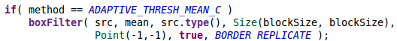

+ ADAPTIVE\_THRESH\_MEAN\_C use for we want to have a binary detail of image but this image have more image noise.

* **ADAPTIVE\_THRESH\_GAUSSIAN\_C:** threshold value is the weighted sum of neighbourhood values where weights are a gaussian window.



+ ADAPTIVE\_THRESH\_GAUSSIAN\_C use for we want to have image less image noise, but this image left more detail of original image.

\* Demo different between **ADAPTIVE\_THRESH\_MEAN\_C** and **ADAPTIVE\_THRESH\_GAUSSIAN\_C**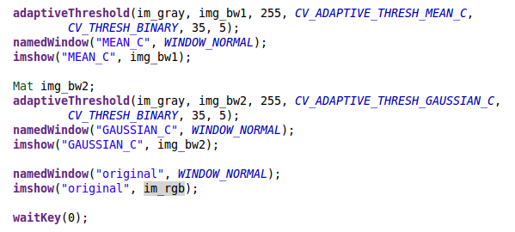

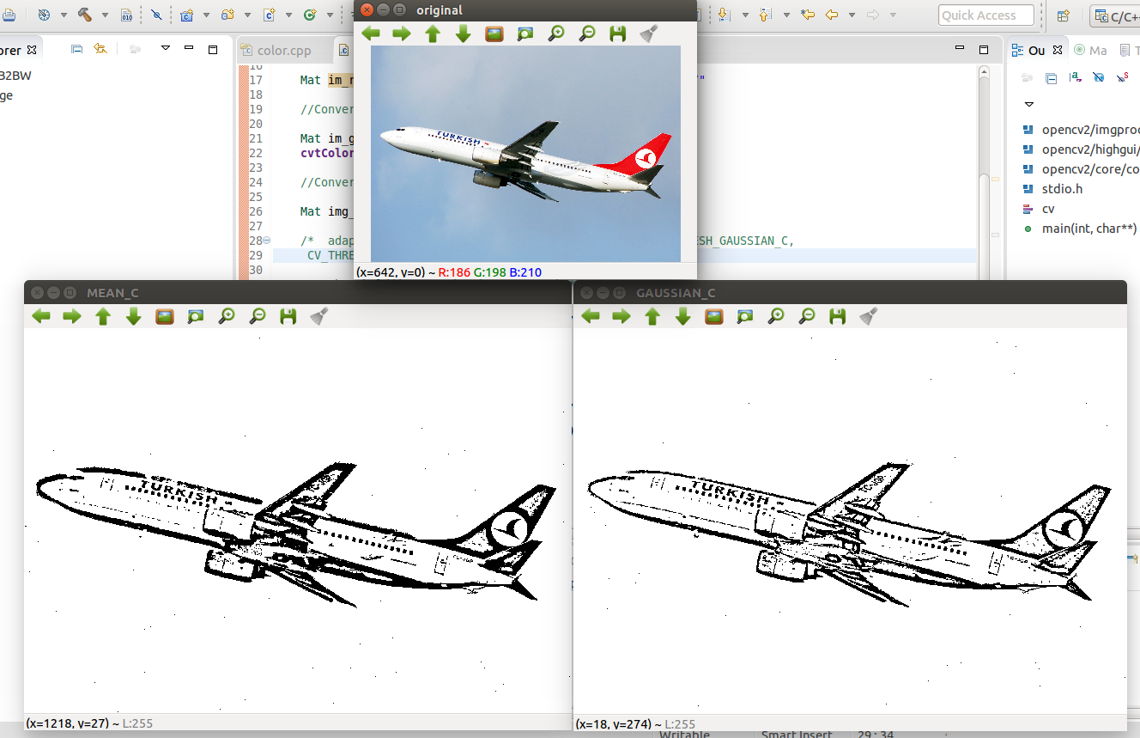

**\* Code Demo converts a gray image to a binary image**

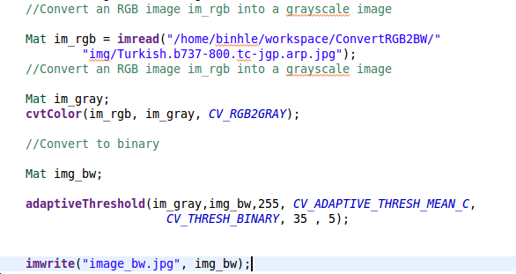

**\* Result**

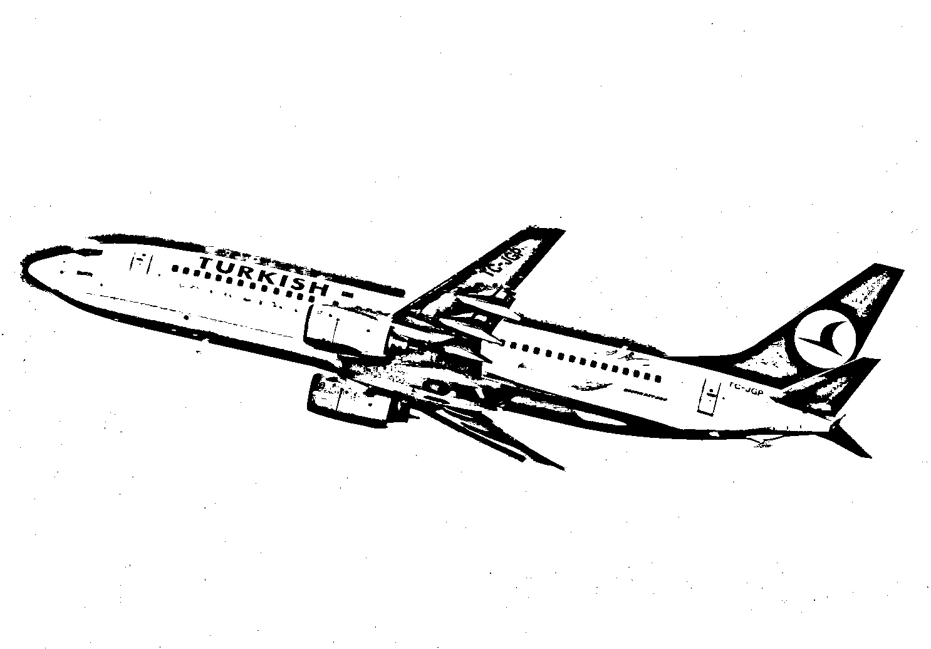

**Finally**, that reasons why we choose convert a gray image to a binary image by **AdaptiveThreshold** with adaptiveMethod is **ADAPTIVE\_THRESH\_GAUSSIAN\_C.** Because this project needs a binary image clear without image noise.

##### Lọc số trong ảnh

Lọc số trong ảnh có ý nghĩa quan trọng trong việc tạo ra các hiệu ứng trong ảnh, một số hiệu ứng nhờ sử dụng các bộ lọc như làm mờ ảnh(Blur), làm trơn ảnh(Smooth) …

Nguyên tắc chung của phương pháp lọc ảnh là cho ảnh nhân chập với một ma trận lọc,

*Idst= M\*Isrc*

Isrc, Idst là ảnh gốc và ảnh sau khi thực hiện phép lọc ảnh bằng cách nhân với ma trận lọc *M*. Ma trận *M* đôi khi còn gọi là mặt nạ (mask), nhân (kernel). Với mỗi phép lọc ta có những ma trận lọc *M* khác nhau, không có quy định cụ thể nào cho việc xác định *M,* tuy nhiên ma trận này có một số đặc điểm như sau:

- Kích thước của ma trận thường là một số lẻ chẳng hạn 3x3, 5x5 … Khi đó, tâm của

ma trận sẽ nằm ở giao của hai đường chéo và là điểm áp đặt lên ảnh mà ta cần tính

nhân chập.

- Tổng các phần tử trong ma trận thông thường bằng 1. Nếu tổng này lớn hơn 1, ảnh

qua phép lọc sẽ có độ sáng lớn hơn ảnh ban đầu. Ngược lại ảnh thu được sẽ tối hơn

ảnh ban đầu.

Ví dụ về ma trận lọc (ma trận lọc Sobel theo hướng x, y và ma trận Gausian Blur)

$$\left[\begin{matrix}\text{-1} & \text{0} & \text{+1} \\ \text{-1} & \text{0} & \text{+2} \\ \text{-1} & \text{0} & \text{+1}\end{matrix}\right] \left[\begin{matrix}\text{-1} & \text{-2} & \text{-1} \\ \text{0} & \text{0} & \text{0} \\ \text{+1} & \text{+2} & \text{+1}\end{matrix}\right] \frac{\text{1}}{\text{273}}\left[\begin{matrix}\begin{matrix}\begin{matrix}1 & 4\end{matrix} \\ \begin{matrix}4 & 16\end{matrix}\end{matrix} & \begin{matrix}7 \\ 26\end{matrix} & \begin{matrix}\begin{matrix}4 & 1\end{matrix} \\ \begin{matrix}16 & 4\end{matrix}\end{matrix} \\ \begin{matrix}7 & 26\end{matrix} & 41 & \begin{matrix}26 & 7\end{matrix} \\ \begin{matrix}\begin{matrix}4 & 16\end{matrix} \\ \begin{matrix}1 & 4\end{matrix}\end{matrix} & \begin{matrix}26 \\ 7\end{matrix} & \begin{matrix}\begin{matrix}16 & 4\end{matrix} \\ \begin{matrix}4 & 1\end{matrix}\end{matrix}\end{matrix}\right]$$

Công thức cụ thể cho việc lọc ảnh như sau:

$I_{dst}\left(x,y\right)=I_{scr}\left(x,y\right)*M\left(u,v\right)= \sum_{u=-n}^{n}{\sum_{v=-n}^{n}{I\left(x-u,y-v\right) ×M(u,v)}}$

Trong đó, ta đang tính phép nhân chập cho điểm ảnh có tọa độ *(x,y)* và vì ta lấy tâm của ma trận lọc là điểm gốc nên *u* chạy từ *-n* (điểm bên trái) và *v* chạy từ *-n* (điểm phía trên) đến *n*, với *n = (kích thước mặt nạ - 1)/2*. Để dễ hiểu hơn ta xét một ví dụ về việc làm trơn nhờ sử dụng một ma trận lọc như sau:

|  |  |  |  |  |
| --- | --- | --- | --- | --- |
| 100 | 100 | 100 | 100 | 100 |
| 100 | 144 | 205 | 203 | 100 |
| 100 | 195 | 200 | 200 | 100 |
| 100 | 200 | 205 | 195 | 100 |
| 100 | 100 | 100 | 100 | 100 |

|  |  |  |  |  |
| --- | --- | --- | --- | --- |
| 100 | 100 | 100 | 100 | 100 |
| 100 | 200 | 205 | 203 | 100  **=**  **pixel (2,2)** |
| 100 | 195 | 200 | 200 | 100 |
| 100 | 200 | 205 | 195 | 100 |
| 100 | 100 | 100 | 100 | 100 |

|  |  |  |
| --- | --- | --- |
| 1/9 | 1/9 | 1/9 |
| 1/9 | 1/9 | 1/9  \* |
| 1/9 | 1/9 | 1/9 |

|  |  |  |  |  |
| --- | --- | --- | --- | --- |
| 100 | 100 | 100 | 100 | 100 |
| 100 | 200 | 205 | 203 | 100  **=**  **pixel (2,3)** |
| 100 | 195 | 200 | 200 | 100 |
| 100 | 200 | 205 | 195 | 100 |
| 100 | 100 | 100 | 100 | 100 |

|  |  |  |  |  |
| --- | --- | --- | --- | --- |
| 100 | 100 | 100 | 100 | 100 |
| 100 | 144 | 167 | 203 | 100 |
| 100 | 195 | 200 | 200 | 100 |
| 100 | 200 | 205 | 195 | 100 |
| 100 | 100 | 100 | 100 | 100 |

|  |  |  |
| --- | --- | --- |
| 1/9 | 1/9 | 1/9 |
| 1/9 | 1/9 | 1/9  \* |
| 1/9 | 1/9 | 1/9 |

…..

Và kết quả cuối cùng ta có :

|  |  |  |  |  |
| --- | --- | --- | --- | --- |
| 100 | 100 | 100 | 100 | 100 |
| 100 | 200 | 205 | 203 | 100 |
| 100 | 195 | 200 | 200 | 100  **=** |
| 100 | 200 | 205 | 195 | 100 |
| 100 | 100 | 100 | 100 | 100 |

|  |  |  |  |  |
| --- | --- | --- | --- | --- |
| 100 | 100 | 100 | 100 | 100 |
| 100 | 144 | 167 | 145 | 100 |
| 100 | 167 | 200 | 168 | 100 |
| 100 | 144 | 166 | 144 | 100 |
| 100 | 100 | 100 | 100 | 100 |

|  |  |  |
| --- | --- | --- |
| 1/9 | 1/9 | 1/9 |
| 1/9 | 1/9 | 1/9  \* |
| 1/9 | 1/9 | 1/9 |

Ta thấy rằng, ảnh ban đầu với là ảnh có độ tương phản khá lớn (các giá trị độ lớn pixel

chênh lệch lớn: 100, 200, …), sau phép lọc ảnh có độ tương phản giản đi hay bị làm mờ đi(lúc này độ chênh lệch giá trị giữa các pixel giảm đi: 100, 144, 167 …). Sau đây ta sẽ xem xét một số bộ lọc trong OpenCV.

##### Lọc trung vị (*medianBlur)*

Lọc Trung vị là một kĩ thuật lọc phi tuyến (non-linear), nó khá hiệu quả đối với hai loại nhiễu: nhiễu đốm (speckle noise) và nhiễu muối tiêu (salt-pepper noise). Kĩ thuật này là một bước rất phổ biến trong xử lý ảnh.

Ý tưởng chính của thuật toán lọc Trung vị như sau: ta sử dụng một cửa sổ lọc (ma trận 3x3) quét qua lần lượt từng điểm ảnh của ảnh đầu vào input. Tại vị trí mỗi điểm ảnh lấy giá trị của các điểm ảnh tương ứng trong vùng 3x3 của ảnh gốc "lấp" vào ma trận lọc. Sau đó sắp xếp các điểm ảnh trong cửa sổ này theo thứ tự (tăng dần hoặc giảm dần tùy ý). Cuối cùng, gán điểm ảnh nằm chính giữa (Trung vị) của dãy giá trị điểm ảnh đã được sắp xếp ở trên cho giá trị điểm ảnh đang xét của ảnh đầu ra output.

Sẽ dễ hình dung hơn bằng mô tả trong hình dưới đây:

[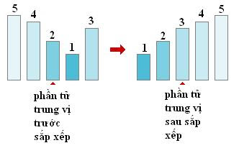](http://2.bp.blogspot.com/_5UXLw8fmChc/Sjyn57hEyrI/AAAAAAAAAZU/cK4CZRAe9zE/s1600-h/t2.JPG)

Sơ lược một cách ngắn gọn các bước của giải thuật:

1. Quét cửa sổ lọc lên các thành phần của ảnh gốc; điền các giá trị được quét vào cửa sổ lọc.
2. Lấy các thành phần trong của sổ lọc để xử lý.
3. Sắp xếp theo thứ tự các thành phần trong cửa sổ lọc.
4. Lưu lại thành phần trung vị, gán cho ảnh output.

**Blurs an image using the median filter.**

void 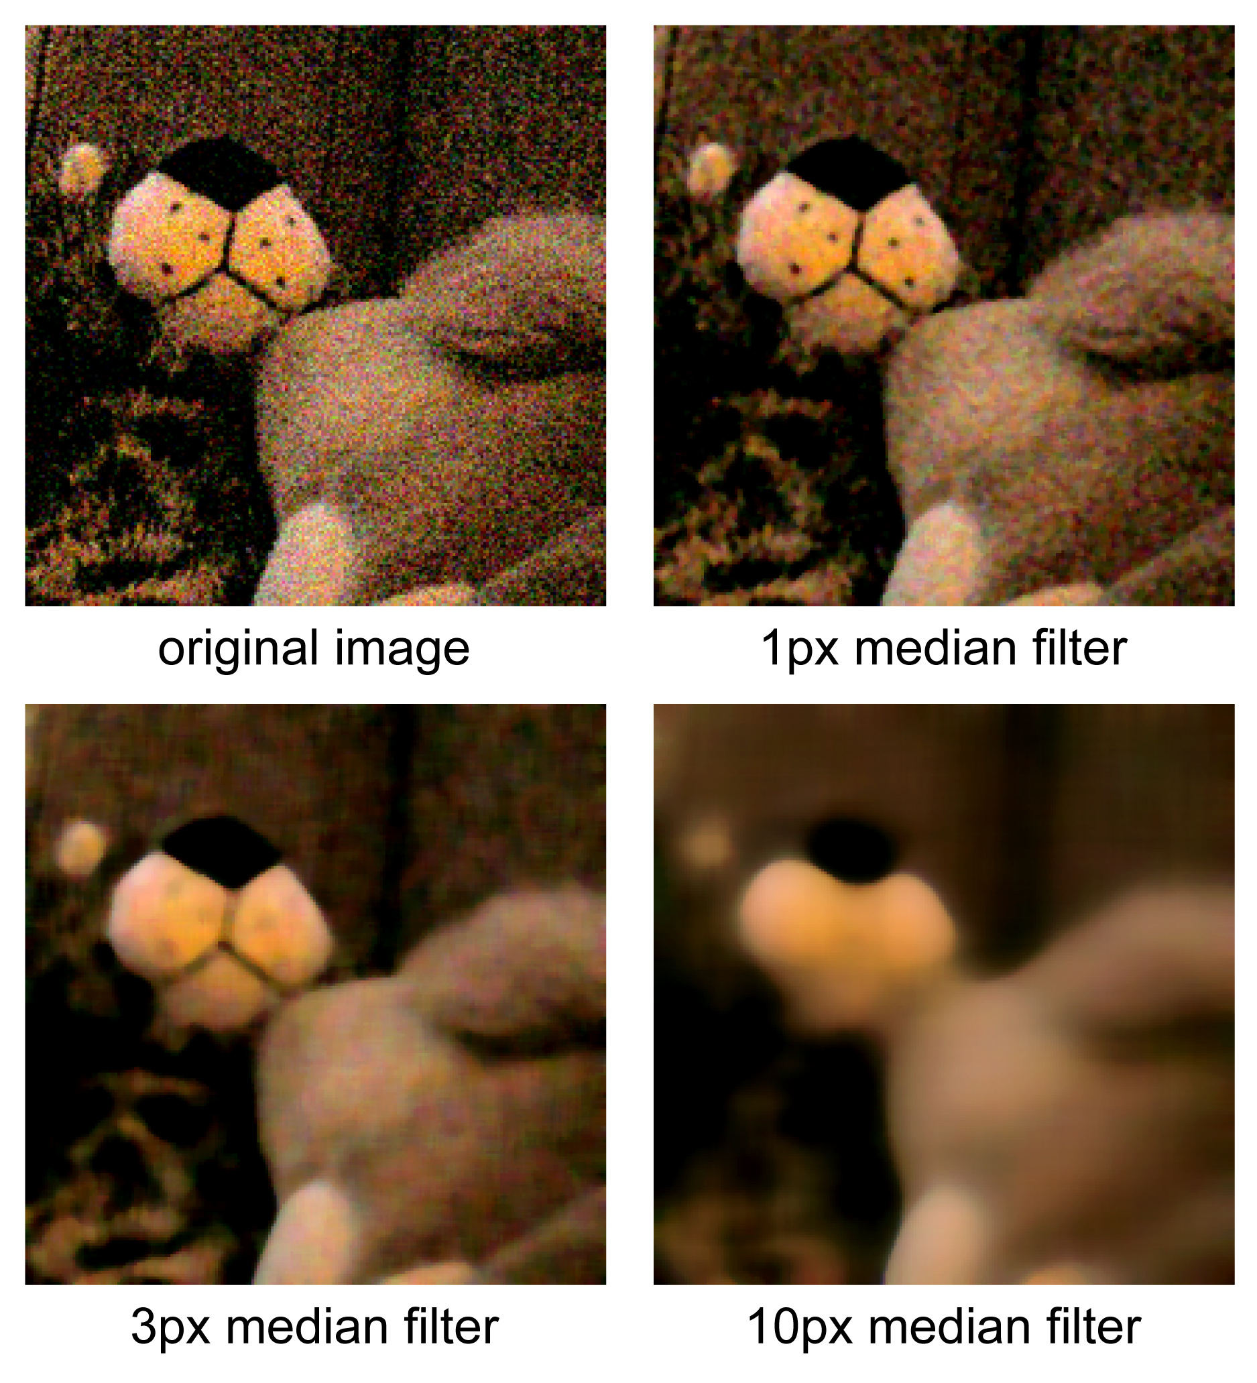**medianBlur**(InputArray src, OutputArray dst, int ksize)

src– input 1-, 3-, or 4-channel image; when ksize is 3 or 5, the image depth should be CV\_8U, CV\_16U, or CV\_32F, for larger aperture sizes, it can only be CV\_8U.

dst– destination array of the same size and type as src.

ksize– aperture linear size; it must be odd and greater than 1, for example: 3, 5, 7 ...

##### lọc Gause

là một loại bộ lọc làm mờ ảnh, sử dụng lý thuyết hàm Gaussian (cũng được biết đến như là dạng phân tán chuẩn (Normal Distribution) trong thống kê) để tính toán việc chuyển đổi (Transformation) mỗi Pixel của hình.

Phương trình hàm Gaussian dùng trong không gian 1 chiều và 2 chiều

$$G\left(x\right)= \frac{1}{\sqrt{2π}σ}e^{-\frac{x^{2}}{2σ^{2}}}$$

$$G\left(x,y\right)= \frac{1}{2πσ^{2}}e^{-\frac{x^{2}+y^{2}}{2σ^{2}}}$$

Trong đó x và y là tọa độ theo hai trục đứng và ngang còn σ là phương sai chuẩn của phân tán Gaussian hay là giá trị quyết định độ lệch giữa các điểm trên 4 bề mặt Gaussian. Trong không gian hai chiều, công thức này sản sinh ra những đường viền là những đường tròn đồng tâm, tuân theo logic phân tán Gaussian từ điểm trung tâm. Giá trị từ hệ thống phân tán này sẽ được sử dụng để xây dựng một ma trận tích chập (Convolution) dùng tính tóan phép tích chập (Convolution) với hình ảnh gốc.

Giá trị mới của mỗi Pixel sau khi tính tích chập với kernel đại diện cho hàm Gaussian có thể coi là trung bình lượng giá của các pixel xung quanh nó. Ta thấy rằng giá trị lượng giá của phần tử trung tâm kernel tương ứng với pixel đang xét là lớn nhất, giá trị này sẽ nhỏ hơn đối với các phần tử tương ứng với những pixel kế cận một cách đối xứng và tỉ lệ thuận với khoảng cách của phần tử này với trung tâm. Tính chất này giúp giữ lại đường viền và biên cũng như làm mờ một cách đồng bộ hơn so với các phương pháp khác.

Trong lý thuyết, hàm Gaussian tại mỗi điểm trên hình là khác 0. Điều này có nghĩa là Gaussian Kernel nên có kích thước bằng với hình ảnh và giá trị tại mỗi phần tử luôn khác 0. Tuy nhiên trong thực hành, do việc tính tóan dựa trên xấp xỉ rời rạc (Discrete Approximation) cho nên giá trị của các phần tử trên bề mặt Gaussian ở khỏang cách lớn hơn 3σ so với trung tâm gần như không đáng kể (tiệm cận 0). Do vậy các phân tán Gaussian ngòai bán kính này sẽ bị bỏ qua, đó cũng là lý do mà thông thường Gaussian kernel có kích thước giới hạn 3, 5, 7 (Cái này còn tùy vào giá trị phương sai chuẩn mà bạn chọn). Khoảng cách giữa hai điểm gần nhau trong Gaussian Kernel là σ. Do đặc tính có cấu trúc như những hình tròn đối xứng, với hình hai chiều, Gaussian blur có thể được áp dụng như là hai phép tính toán một chiều độc lập (Độc lập tuyến tính - Linearly Separable). Có nghĩa là hiệu quả thu được từ tính toán trên ma trận hai chiều có thể tương đương với cách ứng dụng tính toán một loạt các Gaussian 1 chiều theo hướng ngang và đứng. Điều này rất hữu ích trong việc giảm chi phí tính toán thể hiện khá rỏ trong hai công thức tương ứng sau:

Một vấn đề cần được quan tâm nữa của Gaussian blur là nếu bạn sử dụng lần lượt nhiều Gaussian cho một ảnh thì kết quả cũng tương đương với khi bạn dùng một Gaussian lớn hơn có bán kính bằng căn bậc hai tổng bình phương các bán kính của các Gaussian đã dùng, ví dụ: $\sqrt{6^{2}+8^{2}}$ Cũng vì mối quan hệ này mà thời gian tính toán sẽ không thể được tiết kiệm khi bạn chia nhỏ các Gaussian. Do đó khuyến cáo nên sử dụng Gaussian đơn trong tính toán nếu có thể.

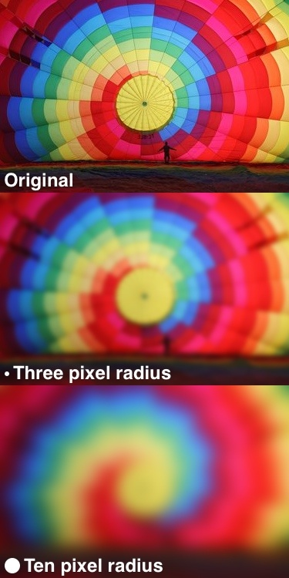

**Blurs an image using a Gaussian filter.**

void GaussianBlur(InputArray src, OutputArray dst,

Size ksize, double sigmaX, double sigmaY=0,

int borderType = BORDER\_DEFAULT )

**Parameters :**

*src* – input image; the image can have any number of channels, which are processed independently, but the depth should be CV\_8U, CV\_16U, CV\_16S, CV\_32F or CV\_64F.

***d****st* – output image of the same size and type as src.

*ksize* – Gaussian kernel size. ksize.width and ksize.height can differ but they both must be positive and odd. Or, they can be zero’s and then they are computed from sigma\* .

*sigmaX*– Gaussian kernel standard deviation in X direction.

*sigmaY*– Gaussian kernel standard deviation in Y direction; if sigmaY is zero, it is set to be equal to sigmaX, if both sigmas are zeros, they are computed fromksize.width and ksize.height , respectively (see [getGaussianKernel()](http://docs.opencv.org/modules/imgproc/doc/filtering.html#Mat getGaussianKernel(int ksize, double sigma, int ktype)) for details); to fully control the result regardless of possible future modifications of all this semantics, it is recommended to specify all of ksize, sigmaX, and sigmaY.

*BorderType* – pixel extrapolation method (see [borderInterpolate()](http://docs.opencv.org/modules/imgproc/doc/filtering.html#int borderInterpolate(int p, int len, int borderType)) for details).

##### Resize images

**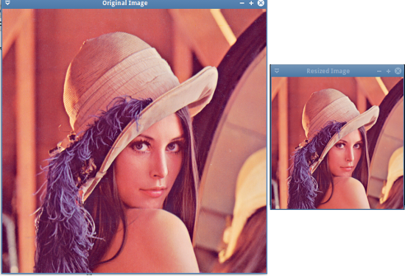**

Digital image is treated as a matrix with pixel values in each cell, so to enlarge an image or shrink an image we can use algorithm which is similar to the matrix. We will use affine to change ratio of the matrix.

Affine transformation :

Vector p =and the matrix M with 2x2 size. Affine transformation in 2D space is defined p’ = Mp include p’ =.

So we have :

$\left[\begin{aligned}x^{'} \\ y^{'}\end{aligned}\right]=\left[\begin{aligned}α \\ γ\end{aligned}\begin{aligned}δ \\ β\end{aligned}\right]\left[\begin{aligned}x \\ y\end{aligned}\right]$

Or

$x^{'}=αx+δy,y^{'}=γx+βy$

In $\left[\begin{aligned}x^{'} \\ y^{'}\end{aligned}\right]=\left[\begin{aligned}α \\ γ\end{aligned}\begin{aligned}δ \\ β\end{aligned}\right]\left[\begin{aligned}x \\ y\end{aligned}\right]$ if δ = γ = 0, so x’ = αx and y’ = βy, this transformation change ratio of the matrix. The following picture describe the tranformation with ratio α = β = 2.



**Resize an image using a Resize().**

void resize(InputArray **src**, OutputArray **dst**, Size **dsize**, double **fx**=0,

double **fy**=0, int **interpolation**=INTER\_LINEAR)

|  |  |
| --- | --- |
| **Parameters :** |  |

***src*** – input image.

***dst*** – output image; it has the size dsize (when it is non-zero) or the size computed from src.size(), fx, and fy; the type of dst is the same as of src.

***dsize*** – output image size; if it equals zero, it is computed as:



Either dsize or both fx and fy must be non-zero.

***fx*** –scale factor along the horizontal axis; when it equals 0, it is computed as



***fy*** – scale factor along the vertical axis; when it equals 0, it is computed as



**Interpolation** – interpolation method:

***INTER\_NEAREST***- a nearest-neighbor interpolation

***INTER\_LINEAR***- a bilinear interpolation (used by default)

***INTER\_AREA***- resampling using pixel area relation. It may be a preferred method for image decimation, as it gives moire’-free results. But when the image is zoomed, it is similar to the INTER\_NEAREST method.

***INTER\_CUBIC*** - a bicubic interpolation over 4x4 pixel neighborhood

***INTER\_LANCZOS4*** - a Lanczos interpolation over 8x8 pixel neighborhood

The function resize resizes the image src down to or up to the specified size. Note that the initial dst type or size are not taken into account. Instead, the size and type are derived from the src,``dsize``,``fx`` , and fy . If you want to resize src so that it fits the pre-created dst , you may call the function as follows:

// explicitly specify dsize=dst.size(); fx and fy will be computed from that.

resize(src, dst, dst.size(), 0, 0, interpolation);

If you want to decimate the image by factor of 2 in each direction, you can call the function this way:

// specify fx and fy and let the function compute the destination image size.

resize(src, dst, Size(), 0.5, 0.5, interpolation);

To shrink an image, it will generally look best with CV\_INTER\_AREA interpolation, whereas to enlarge an image, it will generally look best with CV\_INTER\_CUBIC (slow) or CV\_INTER\_LINEAR (faster but still looks OK).